Shetland Islands Council
Children’s Services
Education & Social Care Department
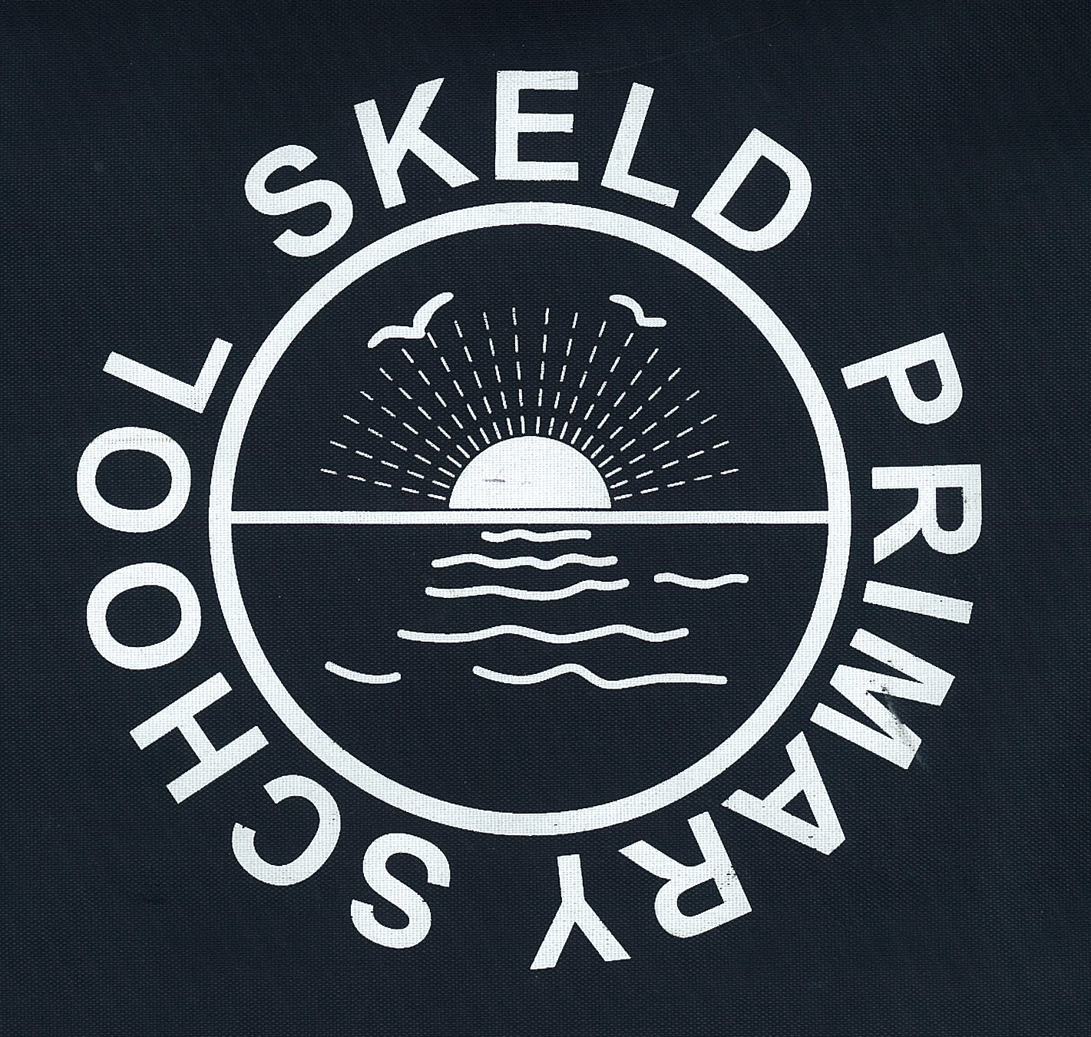

Head Teacher: Mr Stephen Renwick Skeld Primary School, Skeld, Shetland
ZE2 9NL
Tel: (01595) 807480
E-mail: skeld@shetland.gov.uk

Date: 15th November 2023

Dear Parents

As discussed at the last Parent Council meeting we will be having a slightly different parent’s evening this term. We will be available to talk to you if you want to talk to us to rather than calling you in to have a meeting to say everything is fine. If you would like us to contact you, then please do get in touch and we will organise a meeting for you. We are looking at Monday 27th November 2023. We will have a normal parent’s evening in the summer term.

Our next Open day will be on Wednesday 29th November 2023 at 09.45am. This time we will be doing some science - looking at light and shadow. As with the last time, you are invited to stay for a coffee break at 10.45am. I would be grateful if you could let me know if you are able to attend nearer the time.

Please do not worry if you cannot get to this one as we will be having one in the spring term and another in the summer term. We are changing days each time so that hopefully you will be able to make it to at least one.

I am also sending another ‘What three Words’ for you to fill in please. These really do help if we are inspected.

Many thanks

Stephen Renwick
Head Teacher

