**Loose parts activity**

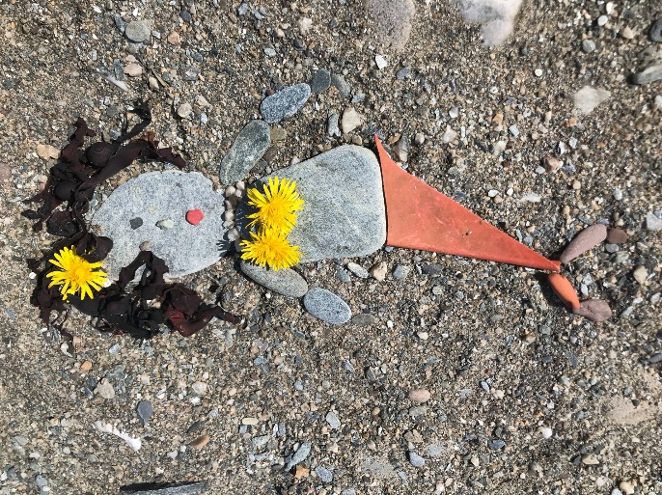Can you make a picture of an animal or sea life creature using items you find on a beach, amongst trees or amongst recycled items?

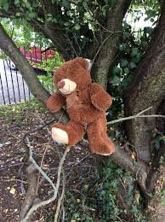Bear hunt

Can you take one of your favourite toys out with you on a walk and tell them about the things you see in your community while you’re walking? Remember to stay safe, wear hi viz and hold a parents hand when you cross the road.

Nature Shapes

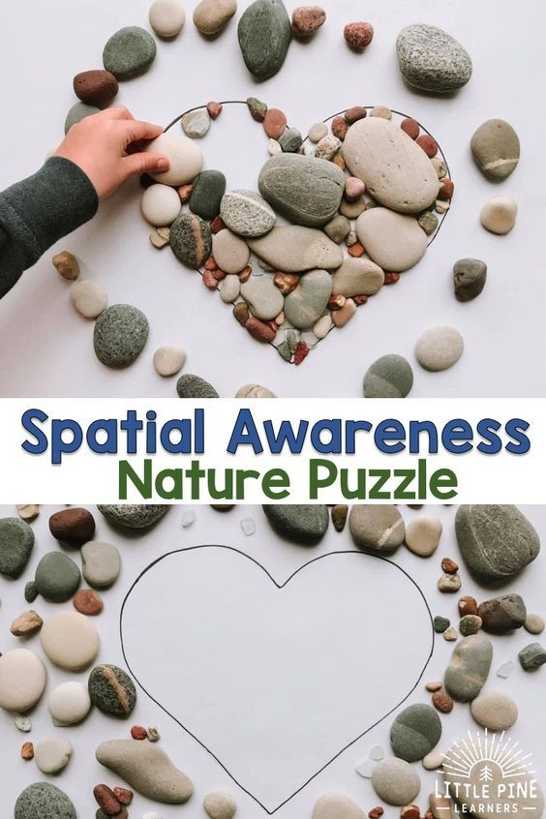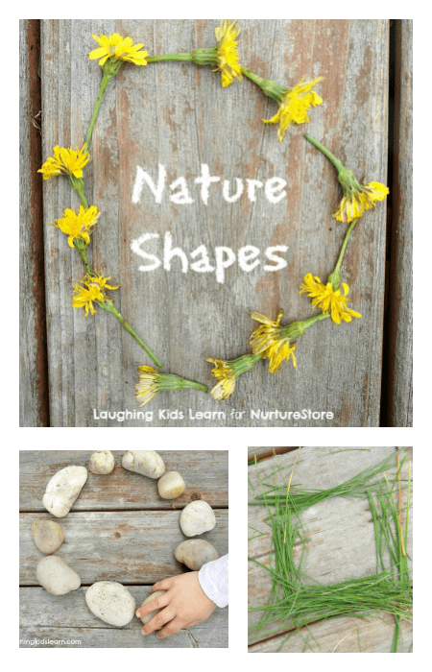

 Nature Faces

Can you do a self portrait using only things from nature?

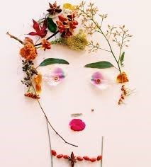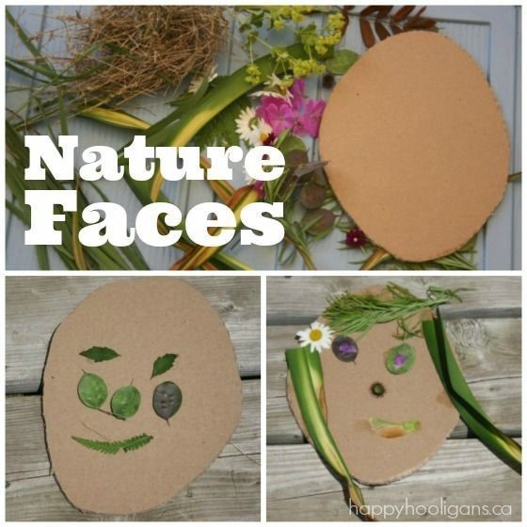

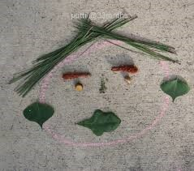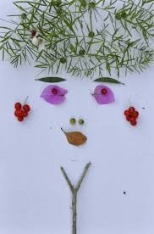

Bug House

Here is a selection of different types of bug houses you can make.  Just use what pieces of nature you have lying around your garden.

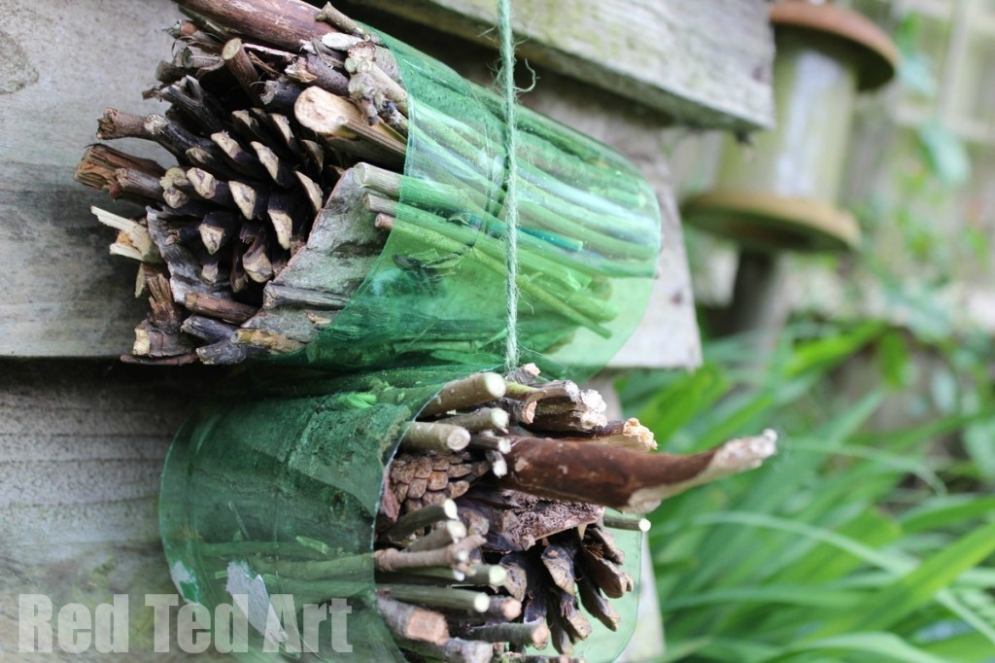

[https://www.redtedart.com/simple-bug-hotel-for-kids//](https://www.redtedart.com/simple-bug-hotel-for-kids/)

