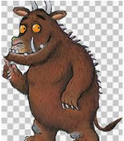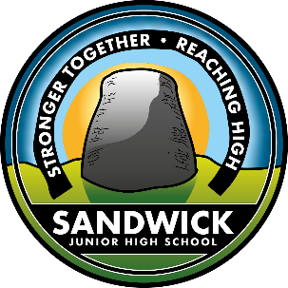[

**These are just ideas you can suggest to your child and see where they take it. Have fun, share what you do on Learning Journals in the ‘parent contributions’ section.**

**Take care and be safe EYD Team**

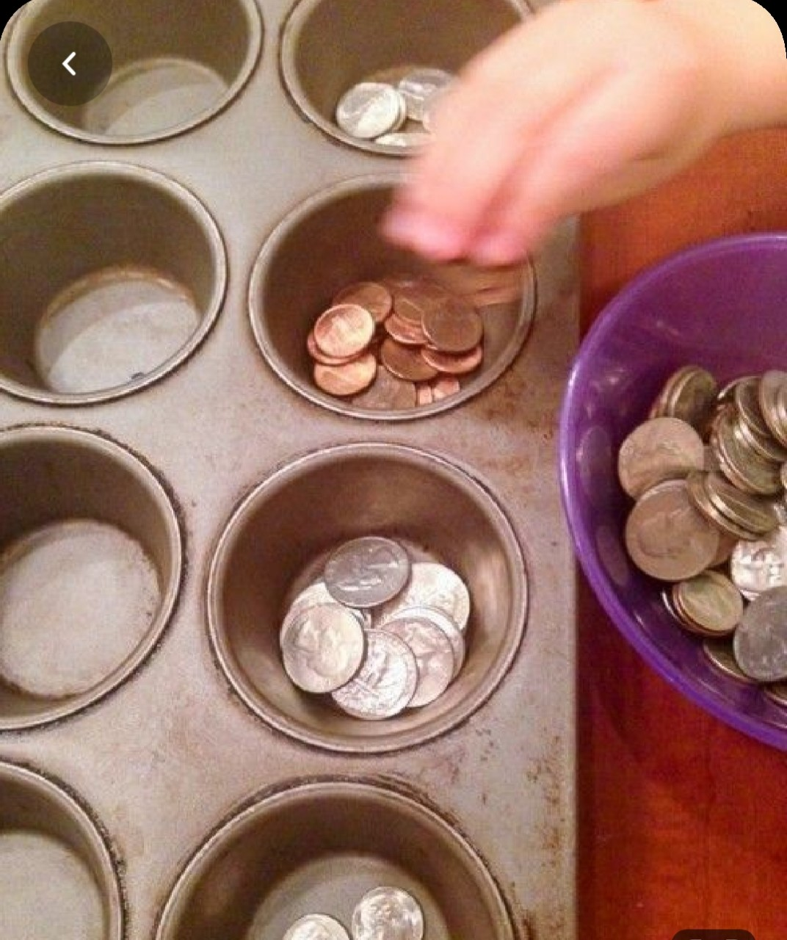

**Numeracy -** Can you find different things around your house and sort them into different groups? Like coins, marbles, or even cut out different shapes and colours from a piece of card. Could you sort them out into matching shapes, or colours? You could use a muffin tray to sort them into. Outside – you could go out into your garden and find stones, or leaves or flowers, do you think you could sort them into different groups too? Then count them to see which group has the most.

Benefits – Shape and colour recognition, counting to 10 (or beyond if able) and fine motor skills

**Rhyme: Jack + Jill. I’m sure you all know this rhyme, can you sing it to your family? Can you draw them? See below for more ideas!** <https://www.twinkl.co.uk/resources/early-years-nursery-rhyme/early-years-nursery-rhyme-nursery-rhymes/early-years-jack-and-jill>

**Phonics - Focus on a sound a week:**

**this week ‘p’**

Have a hunt in house and see what find starting with

‘**p’**. Draw and write pictures starting with ‘**p’**. Can you ‘**pretend play’**, can you paint, take part in ‘**PE**’ activities, ‘**Potato’** stamping, ‘**Paper** **Mache’** and much more.

PE suggestion: Balance – use a bit of thin string or tape along the floor to make a ‘balance beam’. Can you walk along, backwards, sideways. Outdoors a plank of wood, chalk or top can be used. Have fun! How long can you stay on for? Time yourself!

**Literacy –** Could you make an Alphabet Line up! Using some paper or sticky notes or use scissors to cut squares, get a grown up to write the letters of the alphabet on each square. On your wall make a big line of the same letters. Try matching up the letter squares with the letters on the wall!! You could peg them up with clothes pegs or use a little bit of blue tack! Try matching the letters from your name first and then if you can move on and try some of the other letters! Maybe a grown up could write down some other names from your family and you could try and match them on your line up!

Benefits – Adds a little gross motor and fine motor element to alphabet learning having to manipulate the squares, a little bit of exercise having to run back and fore from the table to get each note, scissor skills, and starting to notice the different shapes to the letters by matching!

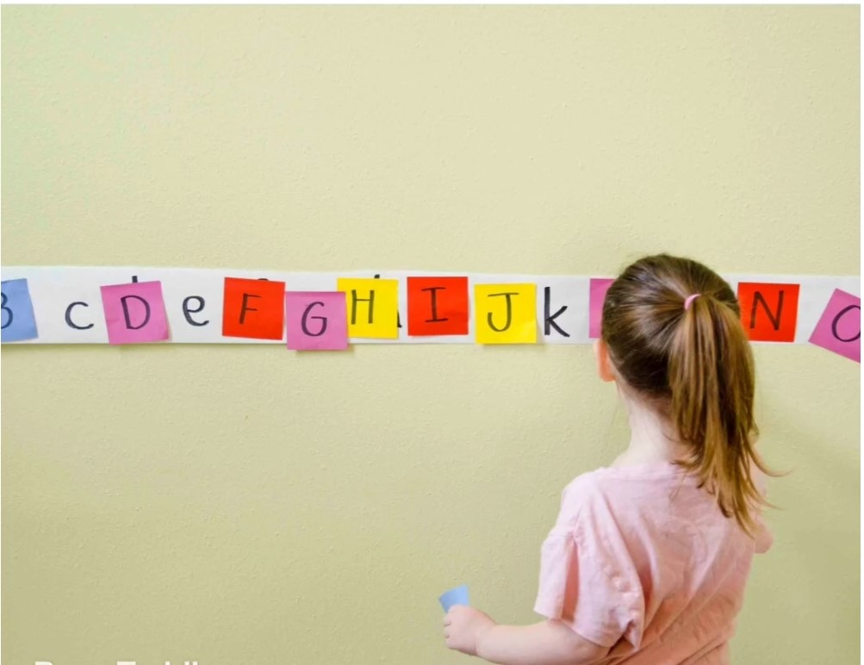

Sandwick Early Years Department

**Home Learning. *Week 5, Term 4 2020***

**Story: A Gruffalo** **read by Tahnae**

**Please go to our blog to see Tahnae read it**

**https://blogs.glowscotland.org.uk/sh/sjhs/early-years/**

**I can enjoy watching, reading or listening to different texts, including stories, songs and rhymes, and can share likes and dislikes**

**I can hear and say rhyming words and generates rhyme from a given word.**

#BuildaBroch At SJH School we are setting a challenge. We would like you to create your very own broch (with you in it), photograph it and share on Learning Journals.

Aim is to make a collage within the school which proudly displays the symbol of our school community**. The broch can be created any way you like i.e. baking, constructing using recycled/household/garden materials or stones/pebbles from the beach**. The choice is YOURS.

Being creative is great for your wellbeing. We saw this very easy activity for making ice cream in a food bag and thought you would love to try it! Its very easy and only takes 10 minutes! Then you can go outside and enjoy it in the sunshine!

All you need is:

120ml milk, 20g Caster sugar, a few drops of vanilla, 120g salt, a medium and a large resealable food bag and enough ice to fill half of the large food bag. Click on the link to see how to do it!! Enjoy! <https://www.youtube.com/watch?v=p89rFfkUUhk>

**.I can hear and say the different single sounds made by letters.**

**.I know the sounds of lowercase and some uppercase letters.**

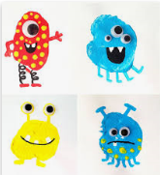



* **I can get ready to prepare food, for example, wash hands, tie hair back, wear an apron**
* **I can prepare and taste a range of familiar and unfamiliar foods**

**I am beginning to demonstrate eye/hand and eye/foot**

**co-ordination required for movement skills, for example, pass object from one hand to the other.**

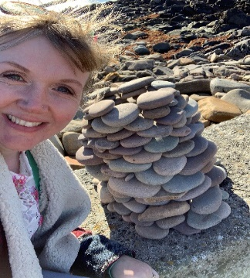

**I can sort and create groups of objects by number.**

*Funnily enough, I made this one with my bairns the day before Mr Manson announced the challenge*

* **I can communicate and shares stories in different ways, for example, in imaginative play.**

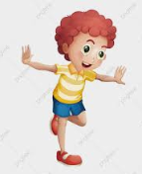

* I can hold balance in various shapes and maintains balance when moving.