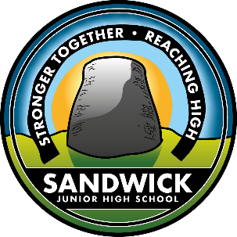 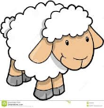

**These are just ideas you can suggest to your child and see where they take it. Have fun, share what you do on Learning Journals in the ‘parent contributions’ section.**

**Take care and be safe EYD Team**

**Ways to promote HWB:**

* Deciding what clothes to

wear outside. Look out the

window at the weather, is it dry, raining, windy. What do you wear on your feet?

* Practise zipping up your jacket yourself. Try 3x yourself before asking for help. Zips can be fiddly but keep giving it a go.
* Being safe on the road, remember Ziggy? He taught us to be safe crossing

the road. Can you tell your Mam + Dad how?

This week we are suggesting a focus on **Health + Well Being.** It is important we look after ourselves and that means learning to do new things, like doing up our jacket, putting shoes on

and washing our hands.

**Rhyme:** Heads, Shoulders, Knees and Toes.

Go over all the different body parts, Can you name them all? Can you

do it fast, or slow?

**Phonics - Focus on a sound a week:**

**this week ‘t’**

Have a hunt in house and see what

find starting with ‘**t’**. Draw and write pictures starting with ‘**t’**. Can you order things from ‘**tiny’** to ‘**tall’**, can you make a ‘**tractor’** out of junk ‘list goes on..!

PE suggestion: Throwing and catching – can you throw a ball to a partner and catch it. If you find this easy, throw a soft ball against the wall and catch it. Count how many time you can throw and catch.

**Numeracy**Outside – Whilst out for a walk can you count the number of lambs you can see in the fields, you’ll have to be quick as they are very fast!! Can you see any black ones?

In the garden – can you count the number of different coloured flowers, what colours are they? Maybe you could count the numbers all together? Can you paint a picture of them and send it to someone special?

**Literacy** – Continue developing your fine motor skills by using items from home. Using a

spaghetti and cheerios you

can practise making towers.

Sandwick Early Years Department

**Home Learning. *Week 3, Term 4 2020***

**Story: Emmas Lamb** **read by Claire**

**Please go to our blog to see Claire read it**

**https://blogs.glowscotland.org.uk/sh/sjhs/early-years/**

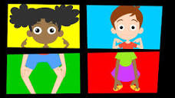

#BuildaBroch At SJH School we are setting a challenge. We would like you to create your very own broch (with you in it), photograph it and share on Learning Journals. Aim is to make a collage within the school which proudly displays the symbol of our school community**. The broch can be created any way you like i.e. baking, constructing using recycled/household/garden materials or stones/pebbles from the beach**. The choice is YOURS.

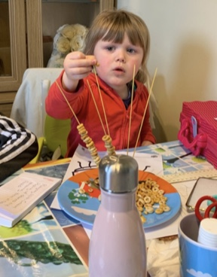

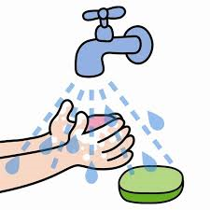

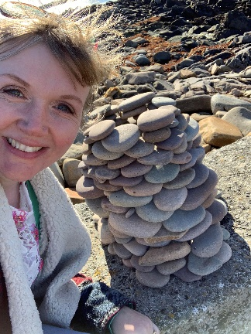

Funnily enough, I made this one with my bairns the day before Mr Manson announced the challenge