**RACE TO 100!** 

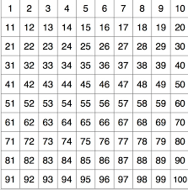

|  |
| --- |
| **Each player has their own 100’s sheet, dice and counter**  **Players go at the same time**  **Roll the dice, do the exercise, move the counter the correct number**  **1 = 7 star jumps**  **2 = 3 burpees**  **3 = 10 jump side to side**  **4 = 4 squat jumps**  **5 = 8 mountain climbers**  **6 = 10 seconds v-sit**  **Can you get to 100 before your partner does?** |



|  |  |  |
| --- | --- | --- |
| **1** | 7 Star jumps | Star jumps.png |
| **2** | 3 Burpees | Burpee.png |
| **3** | 10 Jump side to side | Jump side to side.jpg |
| **4** | 4 Squat Jumps | download.jpg |
| **5** | 8 Mountain climbers | Mountain climbers.jpg |
| **6** | 10 second V-sit balance | V-sit 2.jpg |

RACE TO 100