Family Learning Choice Board

The first activity in each row must be completed.

Choose as many other activities as you would like to do.



Parent signature Date

Learn your

spelling words, use LSCWC or find another way of your choice.

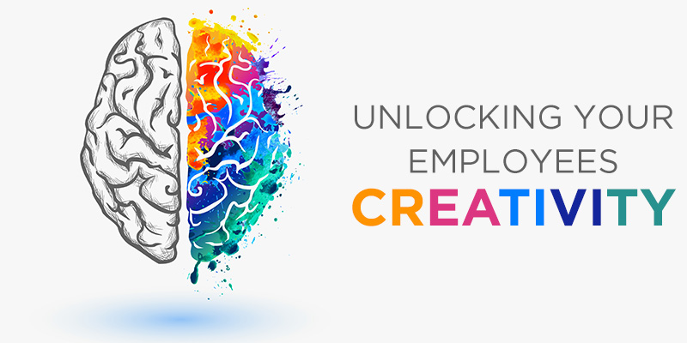

**FITNESS**

Try a home workout, Go Noodle has some great videos!

Look

Say

Cover

Write Check

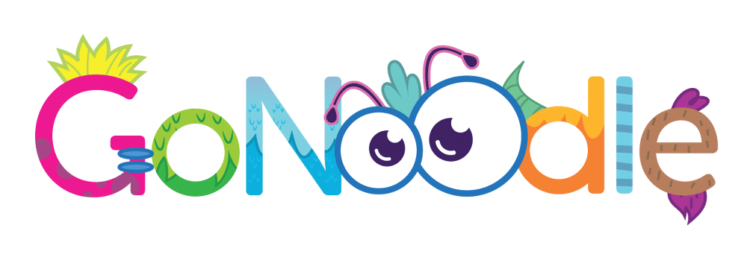



Design a Viking shield with a symmetrical pattern.

Build or make a skeleton using different materials.

**Try 3 new foods and write about the experience.**



**Create your own survey to ask friends and family, show the results in your homework jotter.**

Play Sumdog or Hit the button to improve your mental maths strategies.

Try to guess what foods or drinks you’re eating/drinking when blindfolded by using different senses,

**French**



**Find out the names of different body parts in French.**



**Read your book with an adult.**

**Review the books you read and explain your thoughts.**





**Find out about which emergency services can keep us safe.**



Write a short story with a specific genre: is it scary, funny, full of drama?

**Have your say!**

What is climate change? How can we save our planet?

Learn the Up Helly Aa song ready for SMUHA on

Friday 13th March

**Go on a family walk and take photos.**









**Maths**

Complete your weekly maths quiz in your homework jotter.

**Comment on our school blog!**

<https://blogs.glowscotland.org.uk/sh/sjhs/>

**Look around your home and write down all the 2D & 3D shapes you can find.**

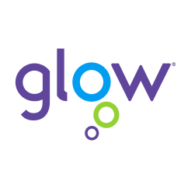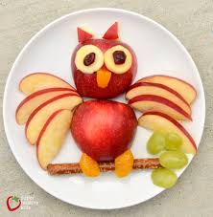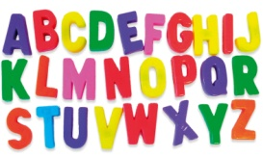

**Art Fun**

Plan something thoughtful for Mother’s Day.

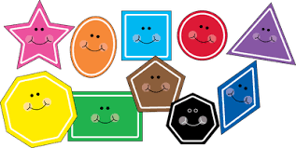



Create some food art!