 Family Learning Choice Board Term 1 Primary 2/3

Please complete the activities within the first column on a daily basis.

Choose as many other activities as you would like to do.

Please use the homework jotter to record what you have done.

The jotter will be gathered in on a Friday and given out on a Monday.





Get someone to help you practice your tricky words

Find out about a person who travelled to the moon.

What do astronauts eat in space? 

Look

Say

Cover

Write Check

Practise your

Spelling words

using the

LSCWC

method



Can you build a space rocket?

For one day make a list of all the things you pull and push through the day!

Play sumdog

to improve

your mental

maths strategies.



**Look at the moon at night and draw what you see. **

**International Sign**

**Read Every Day with an adult**

**Language Day**

**23rd September**

Learn to sign hello and goodbye.

LIFE SKILLS

Help sort your rubbish into the recycling bins.





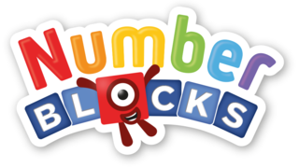**Watch episodes from Series 3 and 4.**

**Play your favourite board game with your family.**

Practise jumping forwards and backwards with numbers, e.g. jump forwards in 2s or 10s.

**RESEARCH**

In the playpark explore push and pull forces. Record your findings and share with the class.

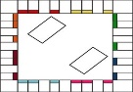

[This Photo](http://specialconnectionhomeschool.blogspot.com/2013/08/free-friday-free-board-game-templates.html) by Unknown Author is licensed under [CC BY-SA-NC](https://creativecommons.org/licenses/by-nc-sa/3.0/)

Play your favourite board game with your family.

Find a song which is linked to our interdisciplinary learning (IDL) – A Journey Into Space.



Go out for a walk and

list the animals you see.

**Save our planet!**

**Can you use less electricity?**

If you can, look at the sky at night with a telescope or binoculars.

Write/draw what you see.

**Spelling Challenge**

Look for words with the spelling sounds we have

been practising.

.





