**The Boxall Profile Online – Guidance Notes for Teaching Staff**

The Boxall Profile is the first step along [the graduated approach to nurture](https://www.boxallprofile.org/about/nurtureuk/) and is the best way to identify and address hidden issues, ensuring that every child and young person gets the support they need to engage fully with their learning. The combination of the assessment tool and the graduated approach helps to create a nurturing and supportive environment, ensuring that children and young people’s emotional and social wellbeing is addressed effectively throughout the different levels of support.

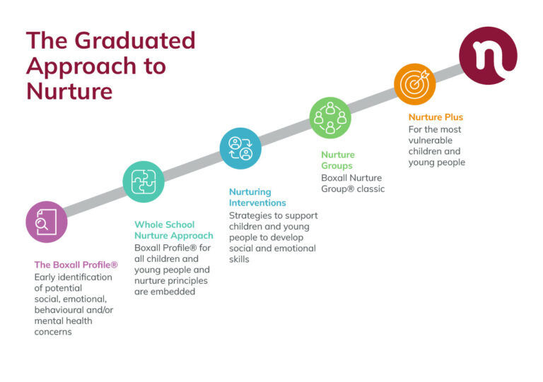

The Boxall Profile is a teacher-led assessment of the social emotional and behavioural difficulties of pupils. It identifies areas of strength as well as areas requiring support for development. The Boxall Profile provides baseline information about the child’s world, allowing teachers to think about what lies behind the behaviour and understand what the child’s real needs might be. Once missing skills are identified, staff can put in place targeted and individualised interventions to help the child or young person to develop these skills.

Boxall Profile assessments are not designed as a diagnostic tool for specific mental health conditions, learning difficulties or developmental difficulties. Instead, assessments are designed to help professionals understand and work more effectively with children and young people, in a way that’s sensitive to the needs of the child or young person being assessed.

The Boxall Profile 2017 can be used to assess primary school children (aged from 3 to 11), and the Boxall Profile for Young People to assess secondary school young people (aged from 11 to 18).

**How to access The Boxall Profile online**

Shetland Islands Council has a local authority Boxall Profile Online licence which covers all schools in Shetland. Each school is assigned permission to access this licence. Invitation emails have been sent to each school office email address. Schools mustrespond to the invitationand register for their licence to be activated. See below:

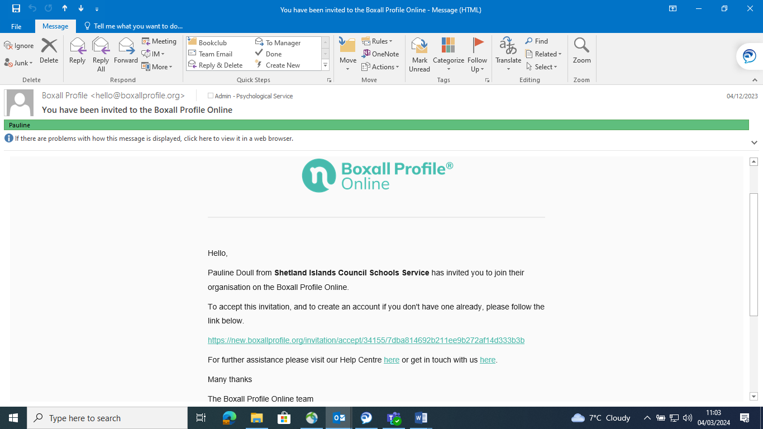

It is important that the account is to be registered using the school office email rather than an individual member of staff.  This ensures that the school is able to access the licence and information should there be any changes in ASN staffing. Once activated, the new login information is to be shared with relevant staff members where they can create new, or access previous, profiles created for their school.  If you have yet to activate your our own school account or have never received an invitation to do so, please contact [pauline.doull@shetland.gov.uk](mailto:pauline.doull@shetland.gov.uk)

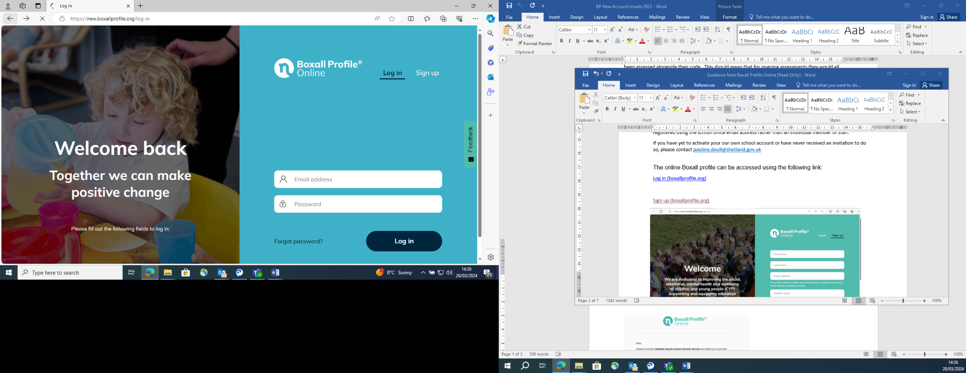

General information about the Boxall Profile is available at:

[SEMH Assessment & Emotional Behavioural Toolkit for Children - Interventions & Strategies (boxallprofile.org)](https://www.boxallprofile.org/)

**Using and interpreting the Boxall Profile**

The Boxall profile has two sections:

1. **Developmental Strands**, consisting of ‘items which describe different aspects of the developmental process of the pre-school years’ (Boxall, 1998)
2. **The Diagnostic Profile**, consisting of items ‘describing behaviours that inhibit or interfere with the child’s satisfactory involvement in school. They are directly or indirectly the outcome of impaired learning in the earliest years’ (Boxall, 1998).

**Section 1: Developmental Strands**

In the first section, the developmental strands are arranged in two clusters:

* organisation of experience
* internalisation of controls

This mainly consists of items which describe aspects of the developmental process from childhood through to adolescence. Satisfactory completion of this first stage of learning is essential if children and young people are to make good use of their educational and social opportunities therefore these aspects MUST be focused on first.

**Section 2: The Diagnostic Profile**

The second section has three clusters:

* self-limiting features
* undeveloped behaviour
* unsupported development

This section consists of items describing behaviours that inhibit or interfere with the child or young person’s engagement with learning. They are directly or indirectly the outcome of impaired learning in the earliest years.

**How to complete and score an Electronic Boxall Profile (EBP)**

The Electronic Boxall Profile should be carried out between two and three times a year, by someone who knows the child or young person best, taking approximately 20-30 minutes to complete.

Creating a new profile is the first step in beginning the assessment. To do this, go to the ‘My Account’ tab and select ‘Manage your organisation’. From here you can create a new class and year group.

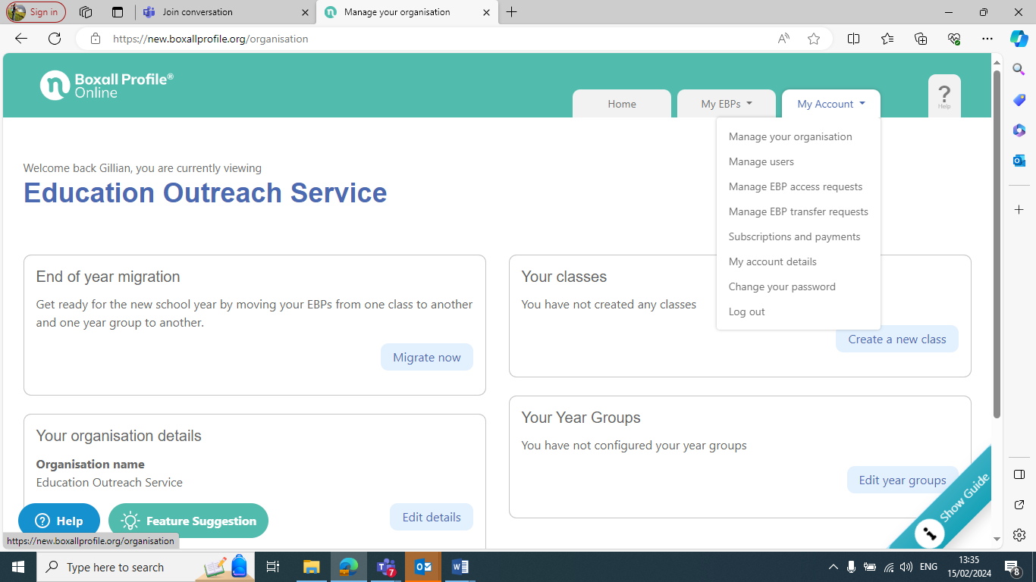

You can now click on ‘Create EBP’ to add the details of each child or young person you are working with. You should create a new profile for any children or young people who have never had an assessment, keeping in mind that users should not use the child’s name. Shetland Islands Council has one licence for all schools in the authority so although schools cannot access specific information about individuals, some information is visible at a generic level. Therefore, users should complete a unique reference code and take a note of this for future reference. It is not a requirement to complete all the additional information asked for if you would feel it would be more useful to focus on the assessment questions initially.

You then select ‘Add assessment’ and complete the individual factors section which might be affecting the overall development of the child/young person. The first section is the Developmental Strands section, with some statements to read and rate on a scale of 1-4. Read each item carefully and answer every question.

Section 2 is the Diagnostic Profile. There are further statements to read and score here with a rating of 1-4 as above.

On completion of the assessment and both sections have been scored, a report is produced.

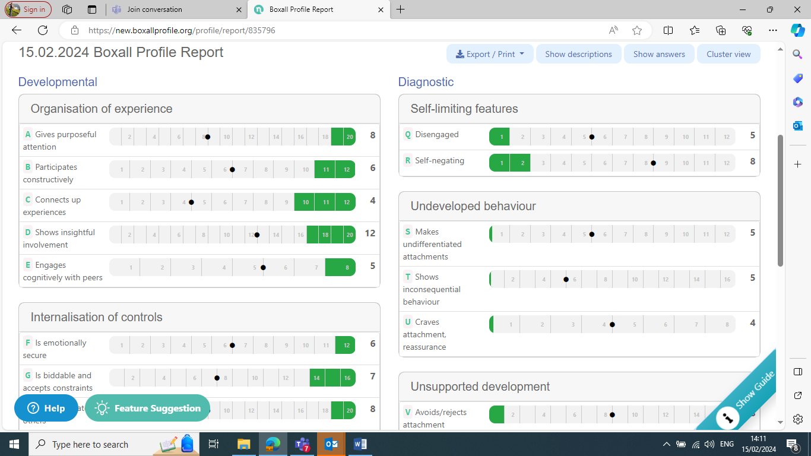

Remember that this is a snapshot of where a particular child is at this time. The green areas show the typical functioning (the norm) in terms of the behaviours and the grey marker or ‘dot’ represents the score of the child/young person.

When interpreting the profile you should consider both strands. Those with nurture needs are likely to have low scores in the developmental strands and high scores in the diagnostic strands.

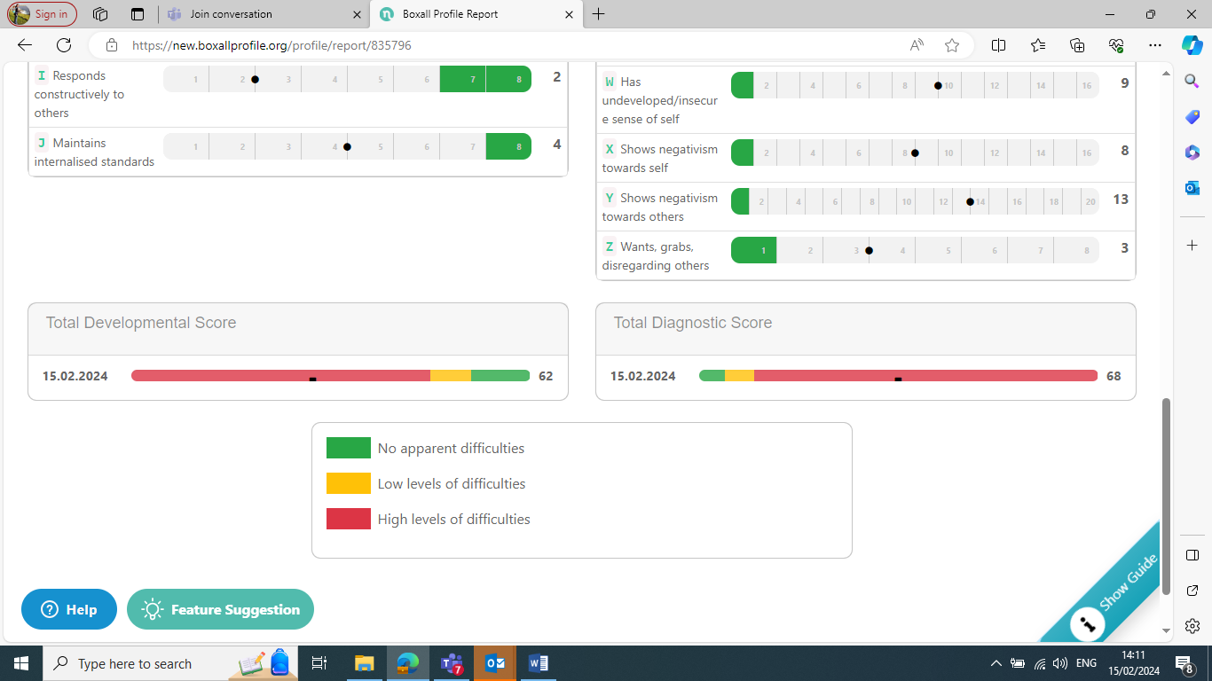

There is an overall score at the bottom of the report. You can click on the ‘Show descriptions’ tab for more information on what each of these statements mean, ‘Show answers’ as a reminder of the scores chosen or ‘Cluster View’ for a summary of the main points.

**Creating a Learning Plan from the Boxall Profile**

At this stage, you will see 5 tabs in the blue ribbon: Assessment, BP Report, Learning Plan, Evaluate and Notes.

It is important to note here that strands in the Boxall Profile are organised alphabetically, in developmental order, and targets should be planned accordingly.

Strands A to E need be developed first, followed by F to J. Strands S to U interfere with the child’s ability to socialise with others. Low scores on V to Z mean that a child or young person displays negative behaviour towards self and others. It is sometimes helpful to imagine it as a wall with building blocks. The foundations (A to E then F to J) must be firmly put in place first. It is recommended to initially focus on 2-3 Boxall Profile strands in a personalised learning plan.

You will see a tab titled ‘Create a learning plan’, click this to begin. Start by selecting the items from the Boxall Profile you wish to target. You can also add in your own. After you have chosen a target, a list of strategies will be suggested. You can select one or two strategies, or again you can add your own.

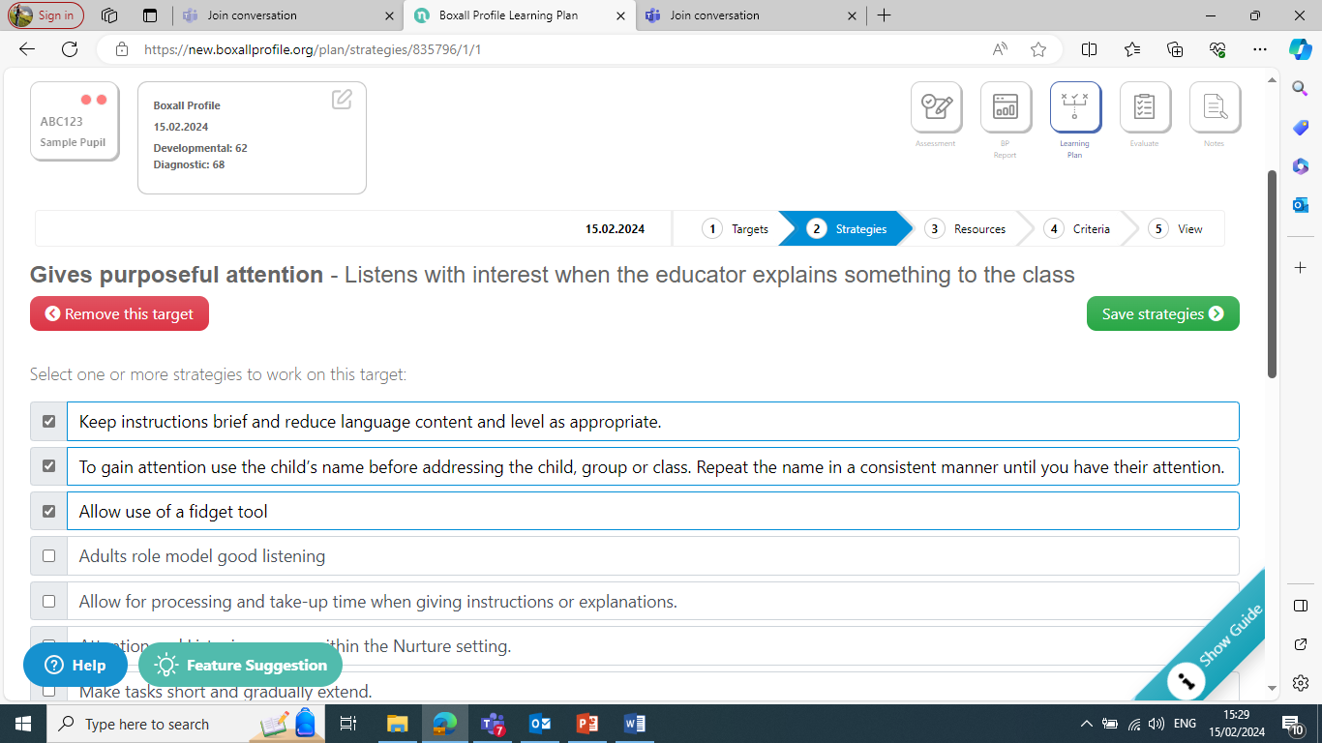

For each target you can click on resources and a list of relevant resources will be shown. You can click on those you wish to use to help you meet your target.

You can then click on ‘criteria’ which will allow you to measure progress. You can select the appropriate box e.g. stays on target for X minutes. Repeat the process to add another target.

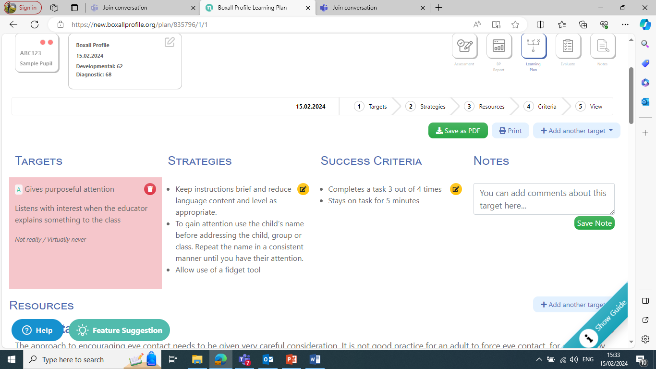

Click on ‘View’ to see the learning plan with targets, strategies and success criteria. There is space to add notes for each.

Please note that the ‘Learning Plan’ part of the assessment is not a requirement and if the team who support the child or young person feel that it would be more beneficial to create their own Learning plan or IEP following the Boxall Report this is also fine, provided that the guidance above is followed. There are lots of suggestions of strategies for each area in the ‘Beyond the Boxall’ resource book which you may find useful (see Resources section at the end of this document). Please ask the Central Inclusion Team or Educational Psychology Service for further information on this resource if you do not have a copy in your school or setting.

Please also be aware that the approach and language of the Boxall Profile Online has been designed to be used by professionals working with children and young people. It is not appropriate to share full assessments and learning plans, or extracts from assessments or learning plans using the formal language used in the profile, with children, young people, parents and caregivers

**Creating Group Overviews**

If you are supporting a number of pupils, organising your EBP’s can help you see the group dynamic, strengths and difficulties across your group.

Click on ‘New group’, give your new group a name and select the EBP’s you would like to include in your group. It can be used to identify the whole group’s needs as well as individual needs. Each row relates to one child and the scores are colour coded in the overview.

Using group or class overviews, teachers can see at a glance the overall social emotional and behavioural strengths and difficulties of the children assessed. This is a key component of the nurturing teacher’s toolbox; it allows teachers to:

* Identify all vulnerable children with high levels of need who would require targeted support.
* Highlight children experiencing minor difficulties that can be addressed directly in class or during small group interventions.
* Gain insight into whole-class dynamics that emerge as a result of common difficulties among pupils.
* Emphasise pupils’ strengths (as sometimes strengths are concealed by difficulties).

As a result teachers become aware of difficulties hindering pupils’ success, they can adapt their teaching to maximise learning and they are able to provide support using whole-class nurturing strategies.

**Reassessment**

Once you have used the strategies for some time (at least for a term, perhaps 6 months), it is recommended that all children are assessed again using the Boxall Profile. This helps to reflect on the progress made or may not have made. It also helps to identify the areas to focus on next and is a way of sharing evidence with other school staff and members of the Senior Management Team.

You may also find it helpful to assess children at the end of the academic year. This would be an opportunity for reviewing the progress made in order to celebrate these achievements or to share at transition meetings.

Please also bear in mind that social emotional wellbeing will fluctuate through the academic year and that children’s lives can be impacted by difficult events at any time. It is important to liase with parents/carers as early as possible to ensure support is put in place before issues escalate into more complex difficulties.

**Resources and Further information**

<https://www.nurtureuk.org/product/beyond-the-boxall-profile-whole-class-strategies/>

[Beyond the Boxall Profile®: Whole-class strategies (for Primary settings) - NurtureUK](https://www.nurtureuk.org/product/beyond-the-boxall-profile-whole-class-strategies/)

[Beyond the Boxall Profile® for Young People: Whole-Class Strategies (for Secondary settings) - NurtureUK](https://www.nurtureuk.org/product/beyond-the-boxall-profile-for-young-people-whole-class-strategies/)