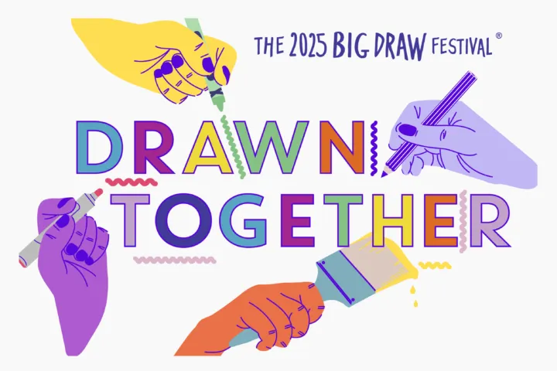
Free donations welcome
you are invited to
Creative Afternoon
with Ringtons & the Big Draw
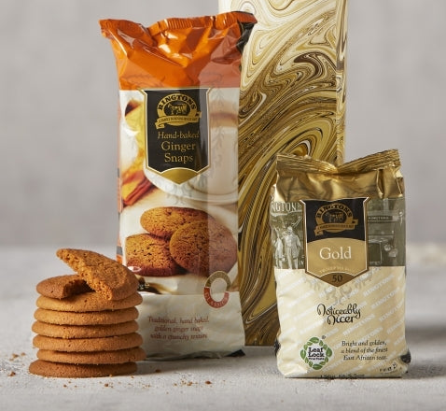
All ages welcome
Come along and create some art, enter the competition and maybe win a fantastic prize! Materials will be provided. Get creative and enjoy a cuppa & biscuits.
Secondary School Art Department
2-4 pm Friday 7th November
Creative Competition closes 16 November

