**Art – Snow days**

Hello – hope you’re all enjoying your time at home. There’s lots of creative things you can do with snow! Here are a couple of ideas. Have fun! Mrs Paul.

**Try building a snow lantern ☺**

I made this one yesterday!

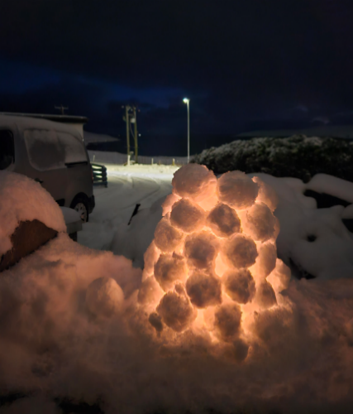Choose a flat surface ( I built it on a wall)

Make snowballs and start with a circle for the first layer

Each layer, position the snowballs slightly more towards the middle, so that you create a kind of cone shape.

Put a small torch or tealight inside before the gap gets too small (adults help will be needed if you’re using a real tealight) -You will also need to leave a small gap to light it if youre using a real tealight.

Build up to the top, carefully pushing the snowballs together gently.

Mine did collapse a couple of times, so you will need patience and good gloves as your hands will get cold!

**Snow pictures**

Snow art – Try drawing a picture and colour in with felt tips, take it outside on a tray, cover with some snow, bring inside and see what happens…

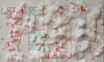

**Out your window**

Have a look outside your window – can you draw what you see? See how the window frames your picture. Use whatever you have, pencils, pens or crayons. You can even use the cardboard form an old cereal packet to draw on if you don’t have paper.

**\*Have fun and send in any pics to your class team** ☺