**Art – Snow days**

Hello – hope you’re all enjoying your time at home. There’s lots of creative things you can do with snow! Here are a couple of ideas. Have fun! Mrs Paul.

**Try making ice tiles/decorations**

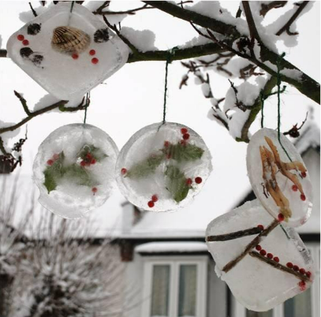Scavenge for nature bits and bobs and foliage. Bird seed is great because when it melts the birdies get fed!

Add these to small containers (like takeaway boxes).

Add a cm or so of water to the container, make sure the foliage is in the water.  Add a loop of string into the water, a little in the water and the rest of the loop out.

Place outside to freeze overnight.  Hang to drip in the sun ☺

**Snow pictures**

Snow art – Try drawing a picture and colour in with felt tips, take it outside on a tray, cover with some snow, bring inside and see what happens…

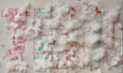

**Out your window**

Have a look outside your window – can you draw what you see? See how the window frames your picture. Use whatever you have, pencils, pens or crayons. You can even use the cardboard form an old cereal packet to draw on if you don’t have paper.

**\*Have fun** ☺