TRICKY WORDS  Play a game of knots and crosses with a grown-up but instead of using x and o choose two tricky words!  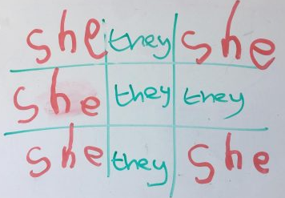 | GUIDED DRAWING  Using a piece of paper, or your jotter, follow along with this clip. Remember to pause it if it goes too quickly for you.  https://www.youtube.com/watch?v=S99MuIXAf7c  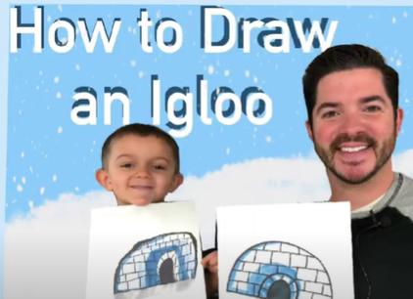 | TOPIC  Watch the video.Which continent do you live in? Which hemisphere would you like to be in? Why?  Geography | KS1 | KS2 | The world | BBC Teach (youtube.com)  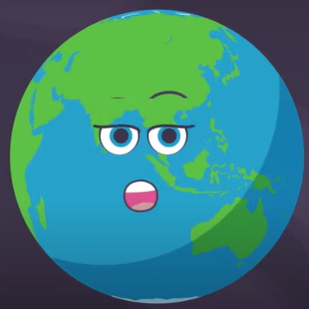
PHONICS POP!  Click on the picture to find a new phonics game. Choose up to 3 sounds and try to pop the bubbles!  https://www.ictgames.com/phonicsPop/index.html | SHAPE REVISION  Cube Cone Sphere Cylinder  Go on a shape hunt and find the shapes mentioned in the video!  https://www.youtube.com/watch?v=guNdJ5MtX1A  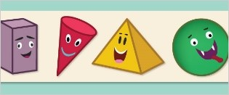 | HEALTH & WELLBEING  Gratitude Chain:  Using strips of paper, create a chain. Add a new link each day, be sure to write one thing you are grateful for on it.  Get the people at home involved too!
ROBOT ADDITION  Practise addition on Topmarks. Explore some other maths games if you’d like.  Robot Addition (topmarks.co.uk)  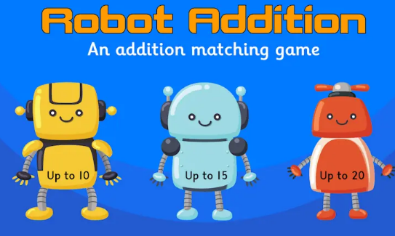 | HANDWRITING  Practise writing your capital letters in flour or outside in the snow with a stick!  Click on the picture to get to Doorway Online to help.  Letter and Number Formation (doorwayonline.org.uk) | SCIENCE  - Cut a piece of kitchen roll into a rainbow shape.  - Use felt tips to colour the ends.  - Hold the rainbow in two glasses of water – one at each end.  - Watch the rainbow light up!

