Page 65

1. List the coins in your change from £1 when you buy

(a) Whistle 25p

(b) Ball 63p

(c) Yoyo £0.77

2. List the coins in your change from £2 when you buy

(a) Aeroplane £1.32

(b) Piggybank £1.05

(c) Bangle 86p

3. How much does each child have left?

(a) I had spent £2. I spent £1.35.

(b) I had £2. I spent 89p.

(c) I had £1. I spent 28p.

4. How much does each of these children have left?

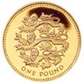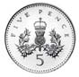(a) Greg had

He spent 90p.

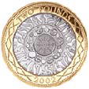

(b) Ray had

He spent £2.80.

5. Suzy bought a toy. She paid with a £2 coin.

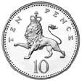

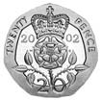

Her change was

How much did she spend?