
Home Learning Grid: Tuesday 6 January 2026

Numeracy | Literacy | Health and Wellbeing
Temperatures are still very low, let’s learn more about negative numbers. Use the link below to find out more:  What are negative numbers?  This game will allow you to practise negative numbers:  Negative Numbers game  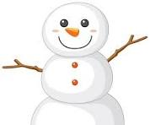 | Can you make any similes and or metaphors to describe the weather?  e.g.  Similes:  The snow covered the ground like a white blanket tucked around the earth.  Snow sparkled like crushed diamonds under the sun.  Metaphors:  The cold was a relentless thief, stealing warmth from everything it touched.  Winter wrapped the world in an icy grip. | Have fun in the snow – can you make a snow sculpture?  You could make a snowman or a snow creature?  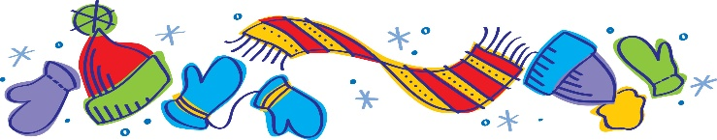
Please only complete these tasks if you are able to do so. Stay safe and have fun!

