
Home Learning Grid: Monday 5 January 2026

Numeracy | Literacy | Health and Wellbeing
It’s very cold outside. Look at the current temperature on the Met Office website. Can you order the temperatures from the lowest to the highest? Which day this week is predicted to have the lowest temperature? Which day is predicted to have the highest temperature?  Lerwick (Shetland Islands) weather - Met Office  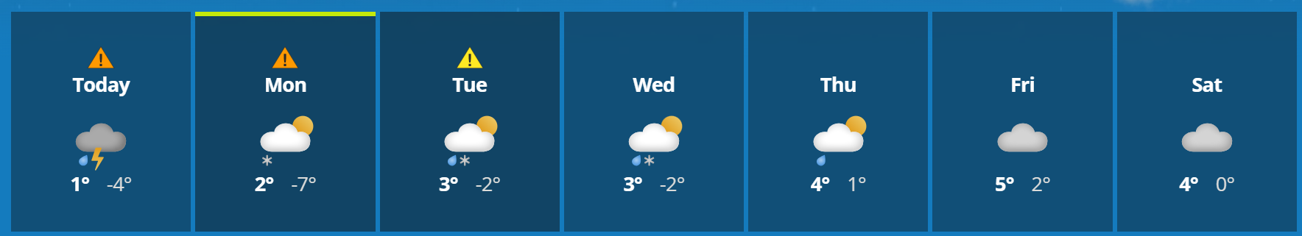  For more practice of different types of number you can log on to Numeracy Workout using the link below:  Username – soundps  Password - share32  Numeracy Workout | Number | Last term we learned about different techniques used in poetry.  Can you write a poem inspired by the snowy weather?  You could even make an acrostic in the space below:  S  N  O  W  Y  J  A  N  U  A  R  Y | Have fun in the snow, you can write in the snow by adding food colouring (if you have some) to a spray bottle filled with water, or use a paintbrush to make some designs in the snow. You could even build a snowman or an igloo!  Have fun!  
Please only complete these tasks if you are able to do so. Stay safe and have fun!

