Home Learning Grid Friday, 19th January P6
Numeracy | Literacy | HWB
Mental Maths Assignment  Learning Intention: I can add, subtract, multiply and divide mentally.  Let’s finish up the week with some mental maths.  Answer the questions in the attached Class Notebook page. You should be able to type your answers straight into the page.  Remember to hand in your Assignment once completed!  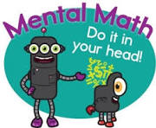 | Victorian Toys Reading Comprehension  Read the information about Victorian Toys on the attached Class Notebook page then answer the questions.  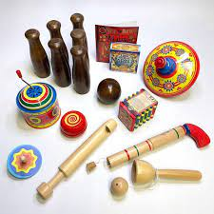 | Design your own Up Helly Aa shield  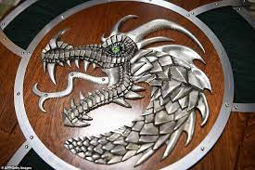  It’s that time of year again. Very soon, we’ll have an invasion of Vikings at Sound School!  Take some time to design your own shield. Draw a sketch of your idea and make a note of what paper/colours you need. You will have the chance to make these when we return to school.  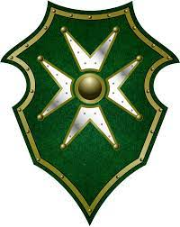
If you need to get in touch, please email me at gw09stockanlee@glow.sch.uk

