Home Learning Grid Thursday, 18th January P6
Numeracy | Literacy | HWB: Outdoor Learning
Winter Olympics Decimals Assignment  Learning Intention: I can read numbers with up to two decimals places  Use what you know about decimals to answer the questions on the Class Notebook page that is attached to your Assignment.  You should be able to type your answers into the Class Notebook page.  Remember to hand in your Assignment once completed!  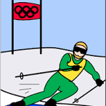  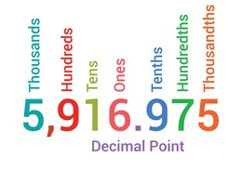 | Winter Sports in Scotland Reading Comprehension  Read the text on the Class Notebook page attached to this Assignment then answer the follow up questions.  You should be able to type your answers into the Class Notebook page. | Plan your own Winter Olympics!  What games can you play outside in the snow with your family or friends?  Here are some ideas…  Make a balance beam out of hard snow and see if you can walk across it without falling.  Follow the leader: snow version. With sturdy boots, make a path in fresh snow. Ask your family or friends to see if they can try to step exactly in your footsteps, to make it look like only one person has walked through the snow.  Hide buried treasure in the snow and see who can find it.  Build a snow game obstacle course, asking friends/family to do things like make a snow angel, jump over a snow mound, toss a snowball at a target.  REMEMBER TO WRAP UP WARM!!!
If you need to get in touch, please email me at gw09stockanlee@glow.sch.uk

