Home Learning Grid Monday 15th January P6
Numeracy | Literacy | HWB: Outdoor Learning
Decimals Assignment  Finding the value of digits in a decimal number  Fill in the table with the value of the underlined digit and then write in words. The first one has been done you for you as an example.  Remember to hand in your Assignment once completed!  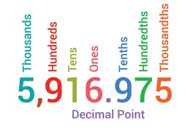 | Victorian Inventors Assignment  As you know, our topic this term is Life in Victorian Times.  Today's Assignment will give you the opportunity to find out more about Victorian inventors and inventions.  Using the Internet to help, match the invention to the inventor and the year it was invented. Then, choose one invention from the Victorian era that you are particularly interested in and find out more information about it.  Record it on the attached Class Notebook page or write it on a piece of paper, take a photo and attach it to this Assignment.  Any questions, please get in touch. | Snowy weather: Nature Detective!  Look for bird and animal prints in the snow.  Draw the prints and identity what creature left them!  