Home Learning Grid Tuesday, 16th January P6
Numeracy | Literacy | HWB: Outdoor Learning
Decimal Digits Assignment  Learning Intention: I can read and write numbers with up to three decimals places  Click on the attached Class Notebook page. Use the suitcases and keys to solve the decimal place value puzzles.  You should be able to type your answers into the Class Notebook page.  Remember to hand in your Assignment once completed!  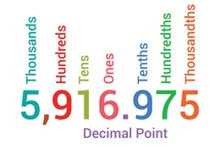 | Homophones Assignment  Remember, homophones are words that sound the same but which are spelt differently.  For example, rain – rein  You should be able to type your answers into the Class Notebook page.  Any questions please get in touch. | Snowy weather: Keeping warm!  Design a scarf, hat and gloves set to keep you cosy during snowy days.  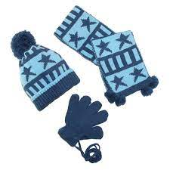
If you need to get in touch, please email me at gw09stockanlee@glow.sch.uk

