Primary 5 Term 1
Primary 5 are a new class this year. Miss Smith has welcomed groups into the playroom where they have had opportunities to play together and develop friendships.
Space
Our topic this term has been Space. We have enjoyed finding out all about the Solar System. In Art they created super collage pictures with Miss Birnie.
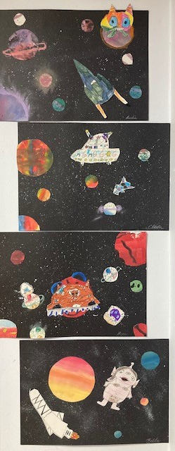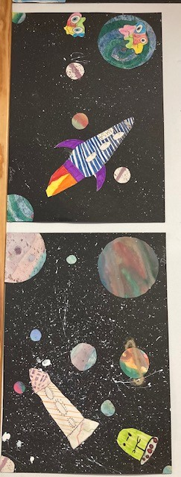

The Northern Lights are a special phenomenon which we are fortunate to see in Shetland. We loved using chalk to create spectacular images to represent the Northern Lights.
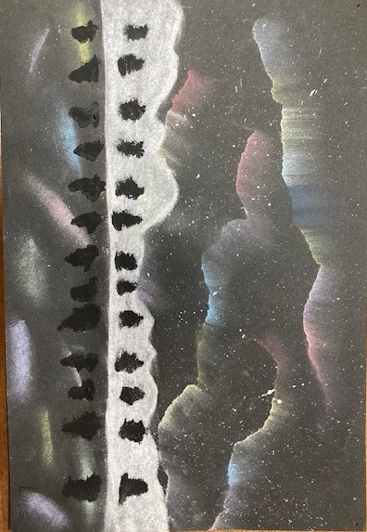
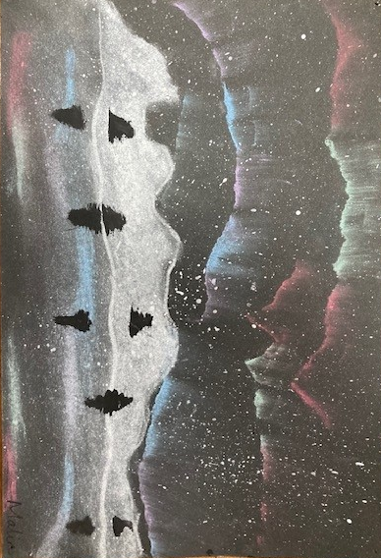

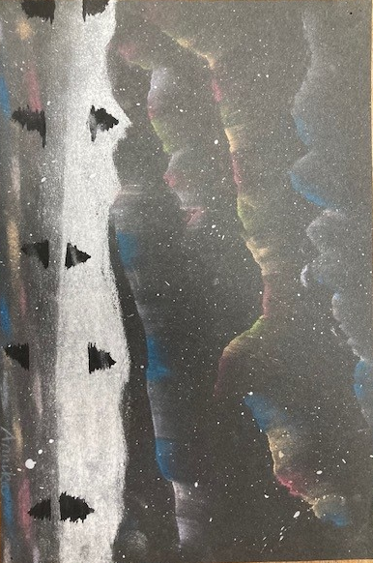

Visit from Mrs Kay and John-Henry
We were delighted to welcome Mrs Kay and her baby boy John-Henry to our class. Mrs Kay has taught all the pupils in the class, some in Primary 2 and some in Primary 4. They are getting on great and will hopefully be back to visit again soon.
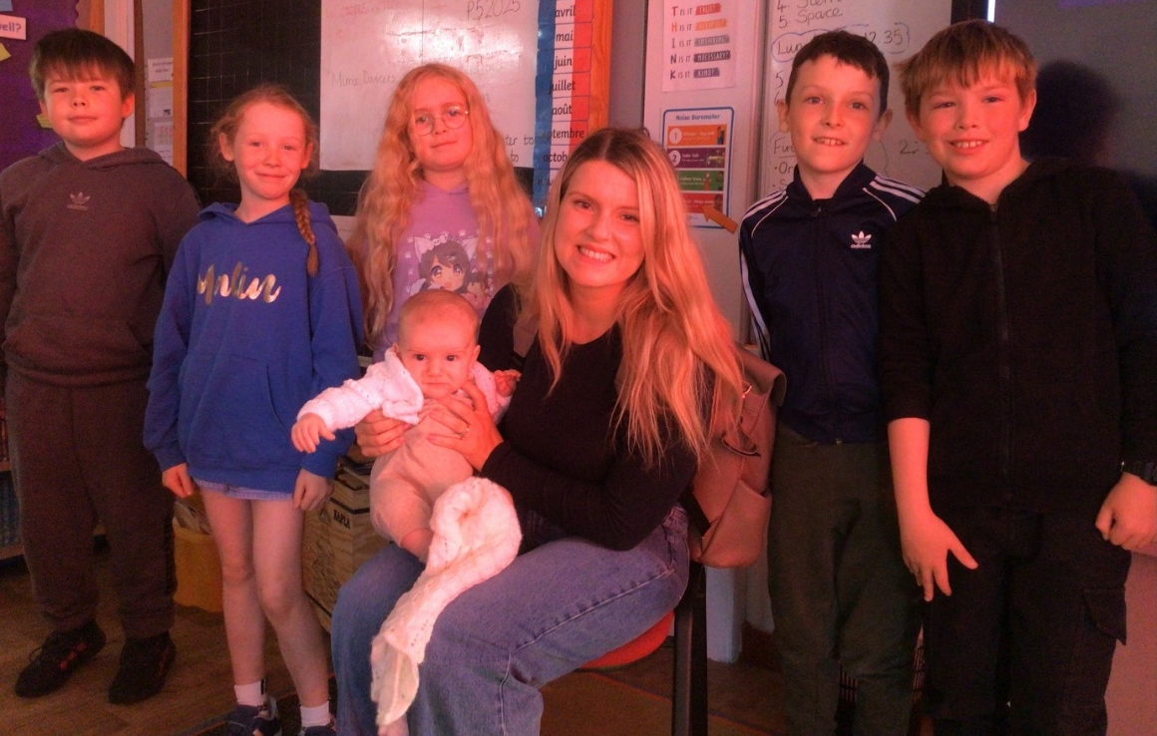

Space Homework
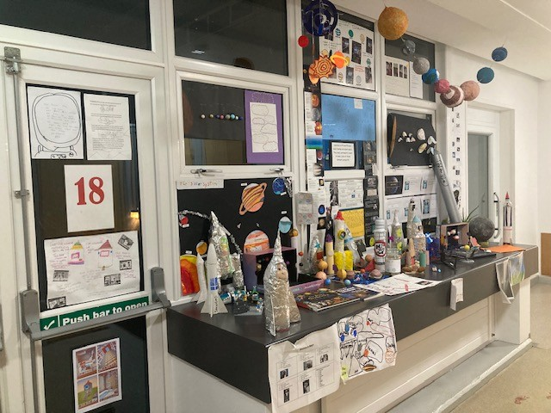
We were amazed with the range of fantastic homework that P4/5 and P5 brought in to share with their peers. We displayed most of it in the Link area at school where their work was admired by everyone.

