Term 2
Halloween
We had great fun at Halloween; dressing up, writing spooky stories and creating Tim Burton inspired portraits.
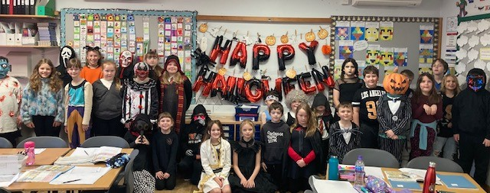
Masks on
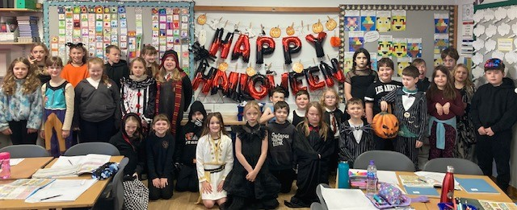
Masks off

Children in Need
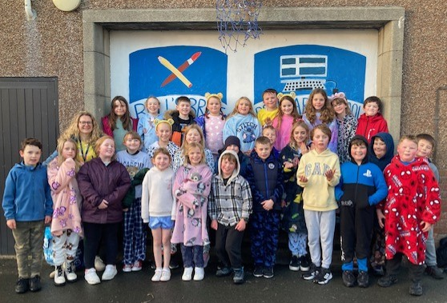
We had a great time on Children in Need Day Friday 14th November 2025. Primary 6 had organised a fantastic range of activities plus a tuck shop and book and toy sale. In the afternoon we were delighted to get a visit from Pudsey, P5 were delighted to exchange a card for Hi 5’s and 6, 7!
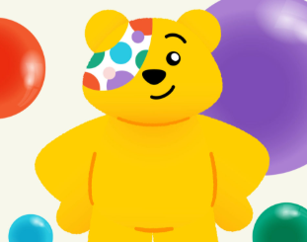
A fantastic total of £863.59 was raised!

