 Snow Day - Home Learning - Term 3 – Week 1 P4
Numeracy | Literacy | Health and Well Being
Numeracy Workout  Login to ‘Numeracy Workout’ online and try some of the activities.  Username: soundps  Password: share32  Top Marks – Revising Time  Telling the Time - Mathsframe | Reading time  Take time today to read a book of your choice. Try to read for at least 20 minutes or so. Relax and enjoy!  Newspaper Article:  Imagine you are a journalist for The Shetland Times newspaper. With the blanket of snow covering Shetland this week, please create a newspaper article, reporting on the adverse weather that is affecting Shetland.  Think About:  School closures  The road conditions  Blizzards, lightning, thunder  The role of the gritters and their crews  Anything else being affected? For example, no rubbish collection in places  Community needs – are some people cut off and how is help getting to them? For example, elderly people. Are neighbours helping those people?  Despite disruption, Shetland looks quite beautiful etc. etc.  Introduction – outline the main point of your article  Middle – making clear and interesting points  End – a concluding paragraph that draws the points together.  Remember, your article will need a catchy caption/title and keep your sentences short and to the point.  If you have any newspapers in your house, take a look at them for ideas to help you or look online at Shetland News.  I look forward to reading your articles!  We are going to be doing more on newspaper articles in class this term. | Fruity Bird Feeder  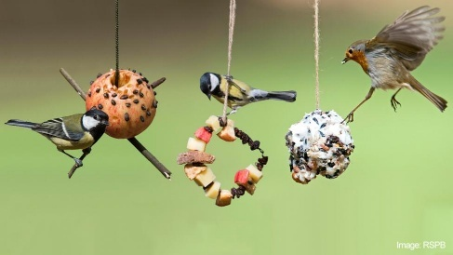  With this snow, the birds will find it difficult to find food so why not try to make a bird feeder to help the birds! I’ve made this feeder before, minus the sticks and string and just laid oranges in planters and other places in the garden and the birds visited them.  Copy the link below to see how to make a bird feeder, if you have the ingredients/equipment at home.  Make a bird feeder - CBeebies  AND/OR  Art  Look out your window today and draw what you see!

