 Snow Day - Home Learning - Term 3 – Week 1 P4
Numeracy | Literacy | Health and Well Being
Sumdog  Login to Sumdog and enjoy working through the various activities.    Top Marks – Multiplication Practise  Hit the Button - Quick fire maths practise for 6-11 year olds | Reading time  Take time today to read a book of your choice. Try to read for at least 20 minutes or so. Relax and enjoy!  Literacy  If you have access to BBC iPlayer, watch the following short film:  The Scarecrows Wedding - BBC iPlayer.  Learning Intention:  We are learning to recount/retell a story in our own words  Success Criteria:  I can write legibly  I can use accurate punctuation  I can spell most words accurately  I can write about events in the correct order  I can use paragraphs  Additional Activity:  One of our school values is ‘respect’. Watch the following short video about respect.  #respectmeans (youtube.com)  It’s ok not to like someone, agree with someone and enjoy different things but despite our differences we all share a basic human right to be treated with respect.  What does respectful behaviour look like and sound like to you? Think about different settings including school, at home and when you’re at clubs or playing with friends.  Have a think about this and write down some of your ideas. We can share everyone’s ideas when we’re back in class. | Snow structures  If safe to do so, get outside and build a snowman, an igloo or something else using snow! Take a picture if you can. We can share your creations with the rest of the class when we get back to school. Please take care and wrap up cosy in this very cold weather.  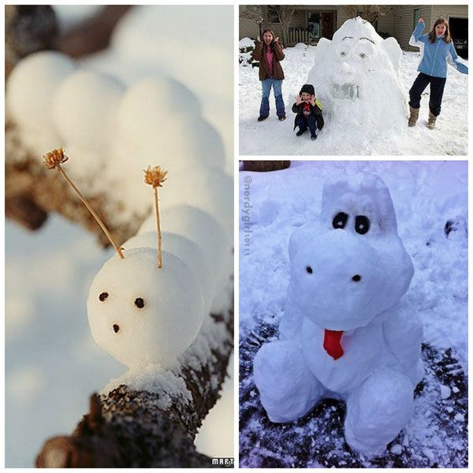  Winter photos  If you can and if it’s safe to do so, using a camera or digital device, take photographs of snow, ice, footprints, paw prints, the sky, winter clothes, trees, birds and any other wintery objects you can see. If you go outside, please have an adult with you on this very cold day! Take care.

