|  |  |  |  |  |
| --- | --- | --- | --- | --- |
| **Technologies**  **Primary 5 - Term 2 - Curriculum Information**   * Internet research for topic * Introduce Micro bits * Coding * Word processing skills – dance mat typing practise |  | **English and Literacy**   * **Reading** – Literacy World, Ginn 360 and Oxford Reading Tree books will be used in class as appropriate * **Vocabulary /Spelling** – This is taught in class and supported by Nelson Spelling **Grammar/Punctuation** – Your child will revise direct speech, apostrophes for possession and adjectives * **Writing** – Your child will write factual reports, short poems and reflective accounts. They will write instructions and describe settings and create posters * **Handwriting** - Practice of joined script will continue * **Listening and Talking** – This will be encouraged in all areas of the curriculum. In particular listening for information and instructions * **Class Novel** The Iron Man by Ted Hughes |  | **Art**   * Class art activities will be linked to the class topic and seasonal topics * Art with Mrs Sinclair - Using block printing materials to create a print of a snowman |
|  |  |
| **Topic: Earth and Space**   * Discussing the creation of Space * Researching the Solar System comparing the size, movement and position of planets * Learning more about the sun, the stars and the constellations * Discovering more about the moon and it’s phases * Researching space travel and astronauts in the past * Following the progress being made locally at the Shetland Space Centre in Unst | **Health and Wellbeing** |
| * PE with Mrs Ritchie – Prioritising core stability and strength in gymnastics * Daily Mile * Daily Emotional Check-in * Shetland Traditional Dance in Teacher Led P.E. time   *Our School Value this term is SAFETY.* |
|  |  |
| **Numeracy and Mathematics**   * Addition and subtraction – adding 1, 10, 100 and 1000 and more on formal method of addition and subtraction * Multiplication and division – short division, doubles, halves, factors, multiples and formal method of multiplication * Angles, symmetry and transformation * Mental Maths, including squared numbers and number sequencing * Time – analogue and digital/24 hour clock/time durations | **Music**  Music with Ms Stewart   * Activities will be related to the class topic ‘space’ and seasonal topics including Christmas Carols |
|  |  |  |

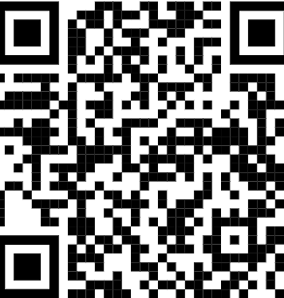

|  |
| --- |
| **German**   * Numbers 1-30, days of the week, months of the year * Greetings and colours |

|  |
| --- |
| **RME**   * Rules, rights, responsibilities and values * Christianity: Advent and the Christmas Story * Morals |

Please use the QR code to access our class blog.