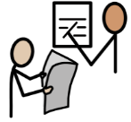  Literacy | Listening & Talking:- we are learning how to work respectfully and communicate with the adults and peers in our school. We will concentrate on when and how to listen and to talk: to wait our turn and follow the new classroom routines.  Reading:- We will concentrate on how to sound out words in our reading books. In topic work we will be learning how to find and use information from non-fiction books.  Writing –We will introduce when and how to use question marks and exclamation marks and will start to assess our own writing. Our topic writing will include creating posters and facts sheets about, “My Amazing Healthy Body” topic.
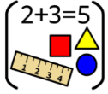  Numeracy & Maths | In number we will be learning about how to count, order, write and make numbers from 0 – 10,20,100 or 1000.  In Beyond Number we are learning to tell the time
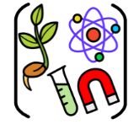  Social Studies/ Sciences | Our Topic this term is “My Amazing Healthy Body.” We will learn about:-  Our skeleton  our organs  keeping ourselves clean  healthy eating and lifestyle  - Germs and diseases
  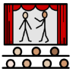  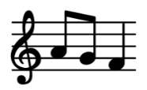  Expressive Arts | Art:  Portrait drawing and Fruit painting
 | Drama:
Music:
- We are beginning to learn how to play tuned percussion instruments.
- Through singing songs about food, I am learning about the concepts pulse and rhythm.
  Technologies | We are learning to name the vocabulary for the important parts of the laptops. We are learning to open word and change the size style and colour of text we have typed.
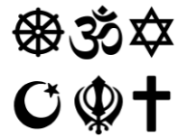  Religious & Moral Education | We are developing our understanding of values such as caring and sharing, fairness, equality and love. We will learn about our school values and how these link to our rights under UNCRC and create a class charter that reflects this.
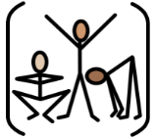  Health & Wellbeing | As part of our topic, we are learning about leading a healthy lifestyle, including how to eat a balanced diet and how to keep ourselves clean..  We will also cover “what makes a good friend” to help us make positive choices.
 | PE Hockey and Basketball

