 Snow Closure Learning Grid 6th January 2026
Literacy | Numeracy | Health and Wellbeing
  Top secret snow mission  You have received a top-secret snow mission.  Mission choices (pick one):  • The snow has magical powers.  • A snow creature needs help.  • School is closed… but something strange happens!  Fun tasks:  • Write a short story (or comic strip!) showing how the mission is completed.  Include:  ⭐ One exciting problem  ⭐ One surprise  ⭐ One happy ending  Add speech bubbles and sound words like CRUNCH! or WHOOSH!  Extra fun:  Read your story aloud in a “storytelling voice.” | Snow closure shop  The snow has closed the shops, so you’re opening your own home shop!  - Chooses 5–8 items to “sell”  - Prices them (e.g. 5p, 10p, 20p, £1 )  - Makes simple price labels  Challenges:  - “I want to buy 2 items. How much altogether?”  - “I have 50p. What can I buy?”  - “Can you make exactly 30p?”  Write quick challenges on paper:  - “Buy 3 items for less than 40p”    - “Spend exactly 25p”  - “What’s the most you can buy with 60p?” | 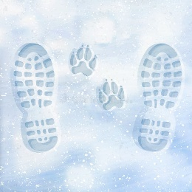  Footprints in the snow  Big question: What makes the deepest footprint?  Make your predictions then head outside and give them a go. See what makes the deepest footprint and record your findings.  Here are some ideas:  - Bare feet or wellies?  - Jumping or standing?  - One foot vs two feet?  - Shoes or socks?  - Tiptoes or flat feet
ENJOY!

