 Snow Closure Learning Grid
Literacy | Numeracy | Health and Wellbeing
Weather Reporter Role-Play  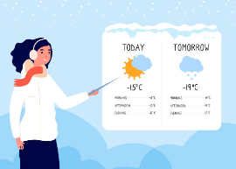  Indoors or outdoors  - Be a weather reporter.  - Describe what you see, hear and feel, Make some predictions about what you think the weather might be for tomorrow and give warnings to those who need it.  - Use words like: icy, swirling, freezing, sparkling, crunchy, storm, windy, north.  - Make a “broadcast” to a pretend camera or family member. | Hot Chocolate Measuring Station  Using hot chocolate powder, cups, spoons, and milk or water:  - Estimate and measure “ingredients”  - Compare full/empty, heavy/light  - Count scoops  - Add some marshmallows, squirty cream and sprinkles.  A brilliant hands-on volume and capacity activity which you can enjoy with your family!   | Melting Race Experiment  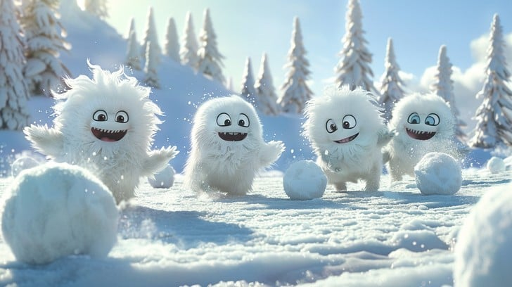  Bring in some handfuls of snow from outside and place in small bowls.  Place one in each:  - A warm room  - A cold room  - Near a window  - Leave one outside  Predict which melts first and why.  Tell someone what you found out in your experiment.
ENJOY!

