Home Learning Grid Friday 19th January Primary 2A
Numeracy | Literacy | Health & Wellbeing
Bingo  This is a favourite in our class. Write down 6 numbers between 1-20 on a piece of paper. Use the spinner (use the link or qr code) to draw the number, remember to click eliminate so you get a new number each spin. Cross off the number if you have it. Once you’ve crossed them all off you shout BINGO!  1-20 Wheel. - Random wheel (wordwall.net) 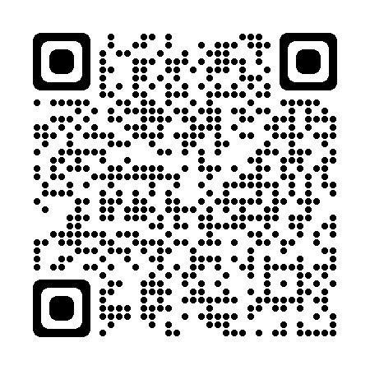  Hit the Button  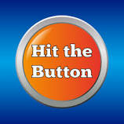  Choose ‘number bonds’ and then ‘make 10’.  Hit the Button - Quick fire maths practise for 6-11 year olds (topmarks.co.uk) | Reading - digraphs  Scan the qr code or click on the link to access the game. Read the words and find the correct picture, there are 3 levels to play.  Pick A Picture (phonicsplay.co.uk)  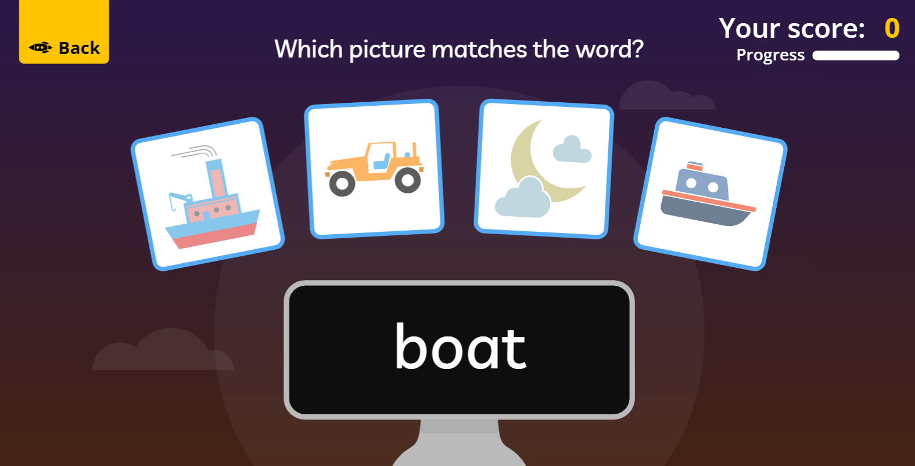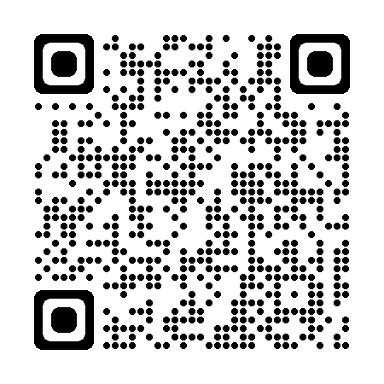  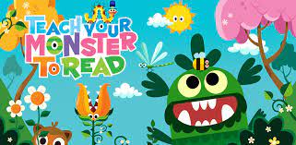  Play some Teach Your Monster to Read if you have access to it. Your login details are in your diary. Login - Teach Your Monster | What is Snow?  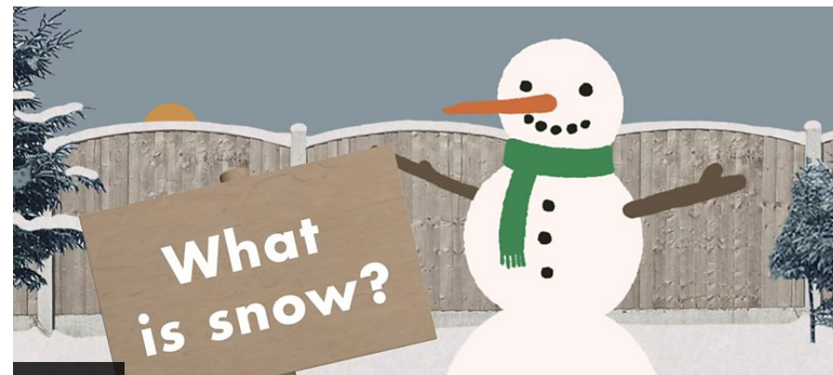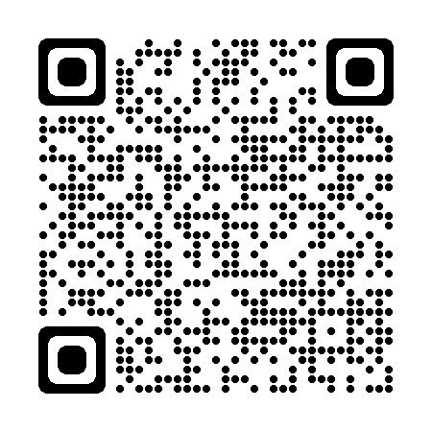  Watch the video on snow. What kind of snow have we had this week?  Where does snow come from? - BBC Bitesize  There is a quiz at the end for you to try.  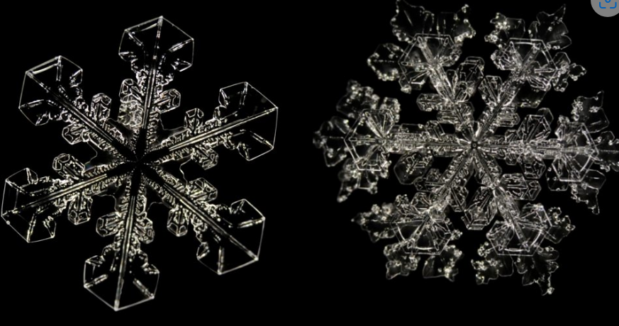  Can you try using your cutting skills to make a snowflake with folded up paper. See if you can make different patterns.

If you have any queries about your child’s home learning, please contact me via my GLOW email account: gw14andersonclare@glow.shetland.sch.uk

