Home Learning Grid Thursday 18th January Primary 2A
Numeracy | Literacy | Health & Wellbeing
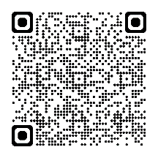  Number bonds for 10  Watch this episode of Numberblocks to help you learn what numbers go together to make 10.  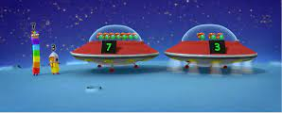  See if you can beat your record on  Hit the Button. I can’t wait to hear what your new records are.  Choose ‘number bonds’ and then ‘make 10’.  Hit the Button - Quick fire maths practise for 6-11 year olds (topmarks.co.uk) | Writing  - Can you draw a picture and write about what your favourite part of these snow days has been? Remember our targets for writing. You could explain to your grown-up what all the symbols mean.  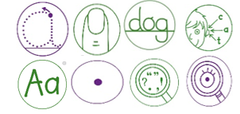  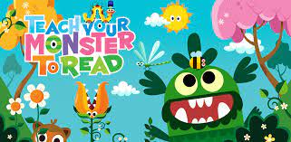  Play some Teach Your Monster to Read if you have access to it. Your login details are in your diary. Login - Teach Your Monster | 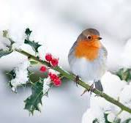  Animals may have a harder time finding food in the snow. If you have any bird feeders at home, you could help fill them up with seeds. If you don’t, if you have any dried fruits, seeds, popcorn or cereal, you could leave these out for animals.  Think about all the jobs your grown-ups do around the house. Is there a job you could help them with today?

If you have any queries about your child’s home learning, please contact me via my GLOW email account: gw14andersonclare@glow.shetland.sch.uk

