Home Learning Grid Wednesday 17th January Primary 2A
Numeracy | Literacy | Health & Wellbeing
Number bonds for 10  Do you know all the number bonds for 10? Get someone in your house to quiz you. They choose a number between 0 and 10 and you need to tell them the number that goes with it to make 10.  If they say 2, you should say 8 because  2 + 8 =10  If they say 5, you should say 5 because  5 + 5 = 10  See if you can beat your record on  Hit the Button.  Choose ‘number bonds’ and then ‘make 10’.  Hit the Button - Quick fire maths practise for 6-11 year olds (topmarks.co.uk) | Snow Spelling  - Can you write these common words in the snow?  the  me  said  you  my  Or spell them another way if you are staying inside.  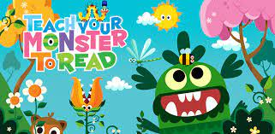  Play some Teach Your Monster to Read if you have access to it. Your login details are in your diary. Login - Teach Your Monster | Snow Angels:  Have you made a snow angel yet?  One of the ways we can show respect is by being polite. Try extra hard to remember to say please and thank you today.

If you have any queries about your child’s home learning, please contact me via my GLOW email account: gw14andersonclare@glow.shetland.sch.uk

