Home Learning Grid Primary 2A
Numeracy | Literacy | Health & Wellbeing
See if you can beat your record on  Hit the Button.  Choose ‘number bonds’ and then ‘make 10’.  Hit the Button - Quick fire maths practise for 6-11 year olds (topmarks.co.uk)  Remember you can use your fingers to help you. There is a video to help any that need it. Number Bonds to 10 with Fingers. (youtube.com) | 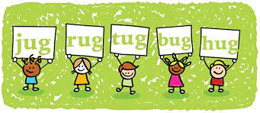  Rhyme Time  - Do you have any rhyming books at home you could look at?  - Does your grown up know any nursery rhymes they can share with you?  - You could play rhyming I Spy. I spy with my little eye something that rhymes with ________?  - Choose a word and come up with as many rhyming words as you can. | Snowman Competition:  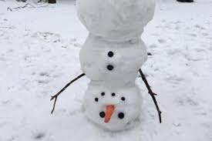  Build a snowman if it is safe to do so! Remember to be safe in the snow.  If you don’t fancy going out in the snow then enjoy some lovely time with the people in your house. You could have some family games time. Choose a fun game you will all enjoy.

If you have any queries about your child’s home learning, please contact me via my GLOW email account: gw14andersonclare@glow.shetland.sch.uk

