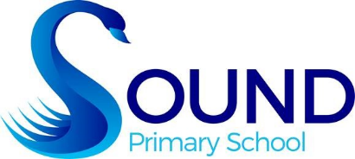P2a Optional Family Learning Grid

|  |  |  |
| --- | --- | --- |
| Reading: Daily – see homework diary for pages to do. | | |
| ICT | Teach Your Monster to Read - Your log in details are in your diaries. | Numeracy: the link for Sumdog is in your homework diary. The Shetland Sumdog contest runs from Fri November 10th until Thur November 16th. |
| Literacy | Practise your letter formation – remember to   * keep all your letters the same size and write on the line. * make tall letters tall. * put the tails below the line. | The Moon Is "Blue" This Wednesday...Or Is It? - Sky & Telescope - Sky &  TelescopeWrite labels on the Moon Phases picture you have made to show what happened.  (see Moon Phases activity below) |
| Numeracy | Baking – measure out the ingredients to make some delicious cupcakes and use the icing to make some stars on top. | Childhood Beckons: Number Line FunMake a giant chalk number line outside – see how far you can count! |
| Other  Our Topic this term is Night and Day. | New Year Fireworks Cartoon Colored Clipart 12902418 Vector Art at VecteezyMake a fireworks picture using bright, fiery colours like red, orange and yellow. | Moon phases – look at the moon every cloudless night to see the different shapes. Try to do it for a month and draw what happens. |
| Diwali – have a meal by candle light to celebrate the festival of light. | Go to the street to see the Christmas lights when they are lit. |



Please share any of your home learning with the school by emailing me - gw14andersonclare@glow.shetland.sch.uk

Photos and information will be added to our P2a class blog throughout the term. Scan the QR code to access it.