Dear Parent(s)/ Guardian(s)
Happy new year to you all.
I have prepared work for your child to complete in the form of worksheets and workbooks for literacy and numeracy alongside a grid of additional tasks, which is available on our class blog.
I have organised most of the tasks into weekly poly-pockets, but some of the jobs are in workbooks. If the job is in a workbook, I have noted the pages to be completed in the information on the next page.
All other work will be on a weekly grid accessible on our blog. This will not need any print outs and I have included a jotter in the blue bag to complete any follow up activities from the grid. There will be a new grid uploaded weekly. There will also be weekly Sumdog challenges for maths for everyone and spelling for P2 only. Your child’s log in for Sumdog is in their red homework diary.
If your child completes all the written work before 1st February, please concentrate on the grids and use the time meaningfully to focus on health and wellbeing.
Our blog is available here:
https://blogs.glowscotland.org.uk/sh/primary12whalsay/
My email address during home learning is:
gw15irvinejayne@glow.shetland.sch.uk
This email is accessible from home; please use it instead of the Shetland Island Council email for any communication during this time.
Oxford Owl is available here:
https://www.oxfordowl.co.uk/
To access reading materials please bear in mind it is case sensitive and log in as follows:
Username: primary1/2whalsay
Password: Whalsay

Try to space out the tasks throughout the week so it is not overwhelming for either you or your child. Do not try to follow a timetable and make home learning ‘like school’, just do what you can, break things into smaller chunks and above all try not to become stressed! I am here to support you and your child so if you have any questions regarding home learning, please contact me on the above email address.
Kind regards,
Jayne Irvine
P1/2 Class Teacher

Primary 1
Week 1: 11th – 15th January 2021
MATHS:
- TeeJay Position and Movement Workbook; p2-6
- Number sheets Workbook p 1 -5
- Sumdog weekly challenge
READING:
- Daily reading of any book you have at home. Try to recognise the letters and words you know and blend the words you can. Reading is important and it is good to practice with lots of different types of books.
- Log onto oxfordowl.co.uk and search for level 1 books. Listen to both “The little Red Hen” and “The Haircut” using the audio feature and complete the activities.
PHONICS:
- Complete the ‘at’, ‘ab’ and ‘am’ word family worksheets.
- Practise your sound book to recognise your sounds.
HANDWRITING:
- Please complete sheets ‘c’, ‘a’, ‘o’
- Number formation numbers ‘1’, ‘2’ and ‘3’.

Week 2: 18th – 22nd January 2021
MATHS
- TeeJay Position and Movement Workbook; p7 – 11
- Number sheets workbook p6-10
- Sumdog weekly challenge
Reading:
- Daily reading of any book you have at home. Try to recognise the letters and words you know and blend the words you can. Reading is important and it is good to practice with lots of different types of books.
- Log onto oxfordowl.co.uk and search for level 1+ books. Read “A home for Ted” and “Tiger’s family” and complete the online activities.
PHONICS:
- Complete the ‘et’, ‘en’ and ‘eg’ word family worksheets.
- Practise your sound book to recognise your sounds.

HANDWRITING:
- Please complete sheets ‘g’, ‘d’, ‘e’
- Number formation number ‘4’, ‘5’, and ‘6’.

Week 3: 25th – 29th January 2021
MATHS
- TeeJay Position and Movement Workbook; p12 – end
- Number sheets workbook p11-15
- Sumdog weekly challenge.
Reading
- Daily reading of any book you have at home. Try to recognise the letters and words you know and blend the words you can. Reading is important and it is good to practice with lots of different types of books.
- Log onto oxfordowl.co.uk and search for level 1+ books. Read “Big, Bad Bug” and “Big Feet” and complete the online activities.

PHONICS:
- Complete the ‘it’, ‘in’ and ‘Ig’ word family worksheets.
- Practise your sound book to recognise your sounds.

HANDWRITING:
- Please complete sheets s and f
- Number formation numbers 7, 8, and 9.

Primary 2
Week 1: 11th – 15th January 2021
MATHS:
- Addition and Subtraction to 20 booklet p324 – 330 (please use number line or counters if needed)
- TeeJay Position and Movement Workbook; p2-6
- Weekly Sumdog challenge.
READING:
- Daily reading of any book you have at home. Try to recognise the letters and words you know and blend the words you can. Reading is important and it is good to practice with lots of different types of books.

- Log onto Oxford Owls and search for Level 2 books. Look at the comprehension sheets in your bag for “The Toys Party” and “Spots” and search for the name of the book. (written on the side of the sheet)
Read the appropriate book and complete the comprehension. Please answer in sentences and use your best handwriting.
PHONICS:
- Complete the sheets on the ‘bl’ blend
- Use Sumdog spelling to practise your skills.
HANDWRITING:
- Please complete letters o, q, and g.
- Tricky words sheet 1

Week 2: 18th – 22nd January 2021
MATHS
- Addition and Subtraction to 20 booklet p 331-335 (please use number line or counters if needed)
- TeeJay Position and Movement Workbook; p7 – 11
- Weekly Sumdog Challenge
READING:
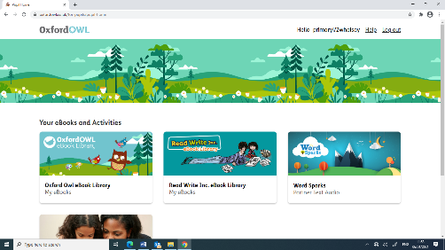
- Daily reading of any book you have at home. Try to recognise the letters and words you know and blend the words you can. Reading is important and it is good to practice with lots of different types of books.
- Log onto Oxford Owl and search for Read Write Inc books.
Read a book daily from the purple section.
PHONICS:
- Complete the sheets on the ‘cl” blend
- Use Sumdog spelling to practise your skills.

HANDWRITING:
- Please complete letters d and e.
- Tricky words sheet 2

Week 3: 25th – 29th January 2021
MATHS
- Addition and Subtraction to 20 booklet p336-339 (please use number line or counters if needed)
- TeeJay Position and Movement Workbook; p12 – end
- Weekly Sumdog challenge
READING:
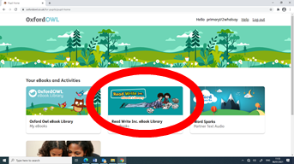
- Daily reading of any book you have at home. Try to recognise the letters and words you know and blend the words you can. Reading is important and it is good to practice with lots of different types of books.
- Log onto Oxford Owl and search for Read Write Inc books.
Read a book daily from the pink section.
PHONICS:
- Complete the sheets on the ‘fl’ blend
- Use Sumdog spelling to practise your skills.
HANDWRITING:
- Please complete letters s and f.
- Tricky words sheet 3.

