My GLOW email address is gw09pottingerkaren2@glow.sch.uk if you have any questions and for sending photos of your work to.

Numeracy | Literacy | HWB: Outdoor Learning
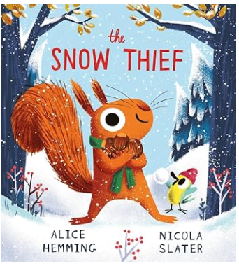
THE SNOW THIEF

Watch the following clip: The Snow Thief ❄️ (read aloud children's book) - YouTube

Draw the squirrel.
Show lots of details…his long ears, thin whiskers, bushy tail.
Notice the adjectives (describing words).

Wrap up warm – can you put your winter clothes on by yourself – have a go, and then take a wander outdoors. Can you see your breath in the cold air? Can you catch snowflakes or hail stones on your tongue? Can you make snowballs or a snow squirrel?


Log on to SumDog and ensure you have completed your initial assessment independently before playing some of the games.

Have fun and I would love to see photos of the work that you have done.

