Home Learning Grid Tuesday 6th January P1-2A
Numeracy | Literacy | Health & Well-being
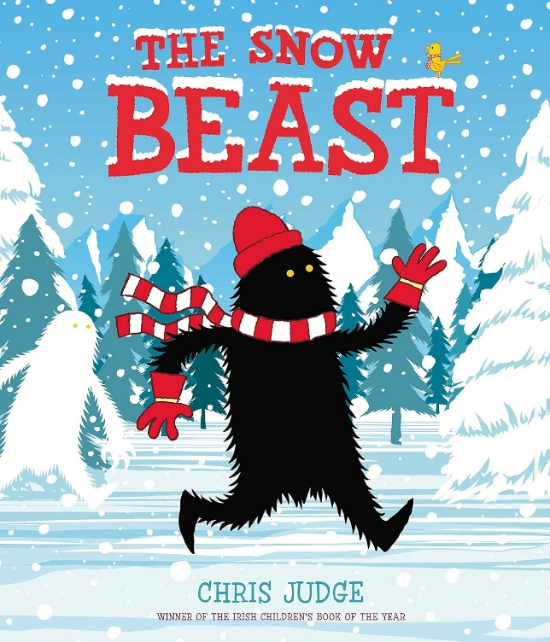
THE SNOW BEAST
Watch the story clip https://www.youtube.com/watch?v=K5ngY93HpzA

Draw me a picture of the Snow Beast helping his village – think what he is doing, why he is doing is and where he is doing it.
Have a go at writing a description of what he is up to.

The snow in the story is deep. Can you find something to measure how deep the snow is round your house?

The Snow Beast makes lots of footprints. Can you see any footprints near you? What do you think made them? Can you investigate the different shapes and patterns made by different animals? You could use books, the internet or look around outside on the ground, walls or other surfaces.

Have fun.

My GLOW email address is gw09stockanlee@glow.sch.uk if you have any questions.

