 Home Learning Grid Monday 5th January 2026 P1-2A
Numeracy | Literacy | HWB: Outdoor Learning
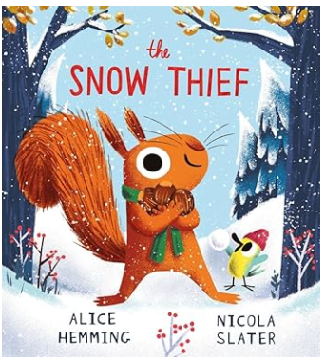
THE SNOW THIEF
Watch the following clip: The Snow Thief ❄️ (read aloud children's book) - YouTube

Draw the squirrel.
Show lots of details…his long ears, thin whiskers, bushy tail.
Notice the adjectives (describing words).

In the story, Bird tells Squirrel that every snowflake is different.
Make a snowflake using a piece of paper.
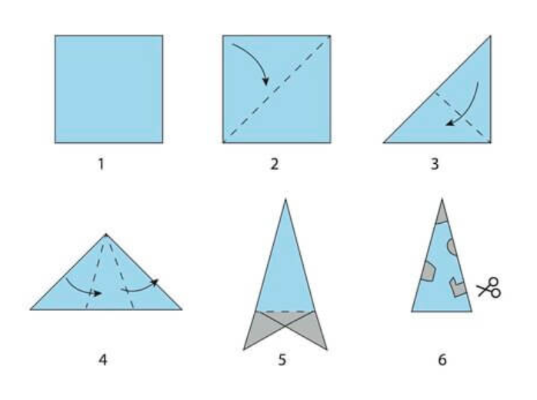

Wrap up warm and take a wander outdoors; can you see your breath in the cold air? If you can, blow bubbles outside. They will be much harder to pop and last much longer. Catch snowflakes or hail stones on your tongue!

Have fun!

