  Literacy | We are learning to write simple sentences using capital letters and full stops.  I am learning new spelling sounds - - Sh, ch, ng, qu, ar  We are learning alphabetical order.
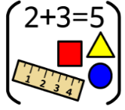  Numeracy & Maths | We are learning numbers to 100 and using these to count, order, sequence and write.  We are learning addition and subtraction to 20.  I can create and continue repeating patterns.
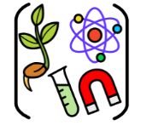  Social Studies/ Sciences | We are learning about “Our School” and the people who work in Bell’s Brae.  We are learning how different people have different jobs in our school which keep us safe, respected and achieving.
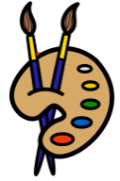  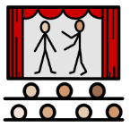  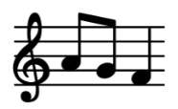  Expressive Arts | Art:  Self Portrait pencil drawing and Flower Still Life
Drama:
We are learning to use drama to explore real and imaginary situations, helping me to understand my world.

Music:
I am learning to sing a variety of songs about harvest and my school.

By completing sound stories and simple dance routines, I am gaining a better understanding of tempo and pulse.
  Technologies | We are using the Interactive Whiteboard and classroom laptops to play games and engage with resources which enhance our literacy and numeracy learning.
  Religious & Moral Education | As we play and learn, we are developing our understanding of what is what is fair and unfair and the importance of caring for, sharing and cooperating with others.
PE
Hockey and Basketball with Respect and Tolerance

