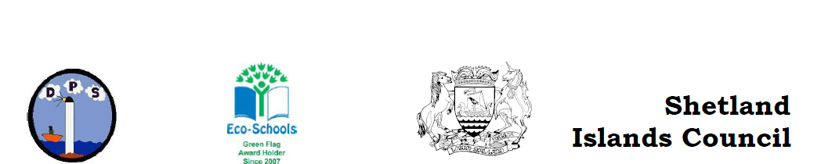

Treasurer’s report

As of 14th September our account balance is £2785.25

A further £200 Cheque is still to be cashed for NOOSC.

We have only had one fundraising activity this year due to the pandemic. “The never get bored book” has raised an amazing amount of £843.50.

As a parent council we have given £200 to NOOSC to replenish their supplies, many of which were depleted during the last accademic year. NOOSC was being used as a hub for key workers children. Which I know was very much appreciated by the parents that had access to this.

A further £150 was given to supply puddle suits for the younger children.

As a thank you to all the staff we provided wipeable easy clean outdoor chairs and a box of biscuits

Sharon
Treasurer DPS Parent Council

