  Literacy | Writing activities based on our Class Novel, Kensuke’s Kingdom by Michael Morpurgo, including: a balanced argument and a persuasive piece to influence others, a diary entry and a book review  Read Oxford Reading Tree texts with fluency and expression  Class discussions and debates
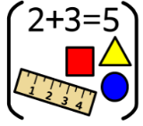  Numeracy & Maths | Place value and rounding of whole numbers (to a million and beyond) and decimals (up to two decimal places)  Negative numbers  Add and subtract whole numbers (to a million) and decimals (up to two decimal places) using mental strategies and written methods  Mental Maths using Numeracy Ninjas
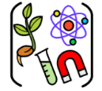  Social Studies/ Sciences | Summarise the difference between weather and climate and identify and describe different climate zones on a world map.  Understand the Greenhouse Effect  Understand the difference between renewable and fossil fuel energy sources  Understand the different types of renewable energy and give the pros and cons of each
    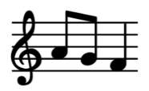  Expressive Arts | Art:  Self portraits  Hokusai inspired ‘Great Wave’
Drama:
Use tone, volume and expression to persuade others during class debates
Music:
We are learning about popular song structure and can perform on a range of classroom instruments using two-handed co-ordination.
We are listening attentively to music that has been inspired by weather/climate and can recognise musical features.
  Technologies | Sign in to GLOW and use the class TEAM  Use Canva to create a timeline  STEM workshop – Lego renewable activity  Collect data from a website and create a table to show the highest carbon producers
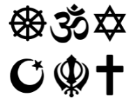  Religious & Moral Education | Discuss ways in which we are contributing to global warming  Understand and plan ways that I can reduce my carbon footprint  Consider the advantages and disadvantages of the Windfarms in Shetland and the impact on the local community
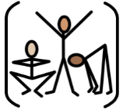  Health & Wellbeing | Team building activities to get to know our class, teacher and class routines
PE
Hockey and Basketball with respect and tolerance

