  Literacy | Comprehension activities based on topic.  Personal Writing. – “All About Me,” “Special Person.”  Consistent use of sentences.  Use conjunctions.
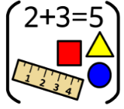  Numeracy & Maths | Addition and subtraction of three digit numbers.  Regular Times Tables practice.  Data Handling.
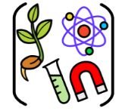  Social Studies/ Sciences | Famous Scientists.  Forces & Friction  Simple science experiments.
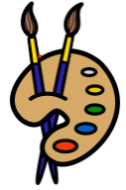  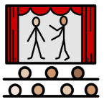  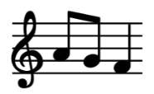  Expressive Arts | Art: Self Portraits.  Cubism
 | Drama: Use a clear voice during class discussion.
Music: We are learning how to play the ukulele and I know how to strum four chords (C, F, G and Am.)
I am learning to sing a variety of rounds/songs and understand how part-songs fit together.

  Technologies | Saving Files in appropriate folders.  Word Processing
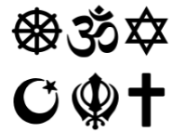  Religious & Moral Education | Explore creation stories from different world religions.
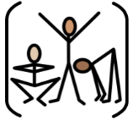  Health & Wellbeing | Balanced Diet.
P.E. Hockey & Basketball.
Team Games

