Snow Day - 7th March – P345
Literacy / Topic  We are going to learn about the ancient Egyptian gods.  There are over 2000 Egyptian gods.  Choose your favourite or the most interesting god or goddess and investigate them using powerpoints and websites I have added, and books you might have at home too.  - Egyptian-Gods-powerpoint.pptx  - BBC BITESIZE- What did the Ancient Egyptians believe in?  - Ancient Egyptian Gods  - Ancient Egyptian Gods & Goddesses  - Gods and Goddesses of Ancient Egypt  Complete a fact file based on what you have learnt about them using the fact file template:  - Ancient-Egyptian God_Goddess Factfile.pdf  If you don’t have a printer, you can design a poster including the information from the template.  Nessy – Those who do Nessy in school can log in and practise for 15 minutes today. | Numeracy  Circles  Practise your number bonds to 100 (e.g. 50+50=100, 20+80=100, 60+40 =100, 30+70= 100).  Practise saying them aloud by someone asking you them. You could draw a picture with the different number bonds to 100 hidden in it.  Click on the following link: https://www.sheppardsoftware.com/math/addition/fruit-splat-game/  Have a go at level 4 and level 5 – relaxed mode, slow fruit.  Squares and Triangles  We are going to continue practising our times tables.  Click on the following link: https://www.timestables.co.uk  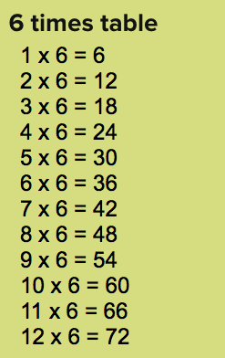  Choose a times table you want to practise.  Write the times table  on a piece of paper.  Complete the activities as you scroll down the page. At the bottom there are 3 games you can choose from.  I would like you to practise 3 different times tables today. Try to challenge yourself! | Health and Wellbeing  Go outside, find some freshly fallen snow and see if you can find some animal tracks. Have a go at identifying them- Animal Tracks in Snow: Identify Animal Prints - Woodland Trust  Send me a photo at  gw18morrisonlynsey1@glow.sch.uk  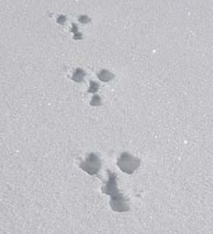  Have fun!

