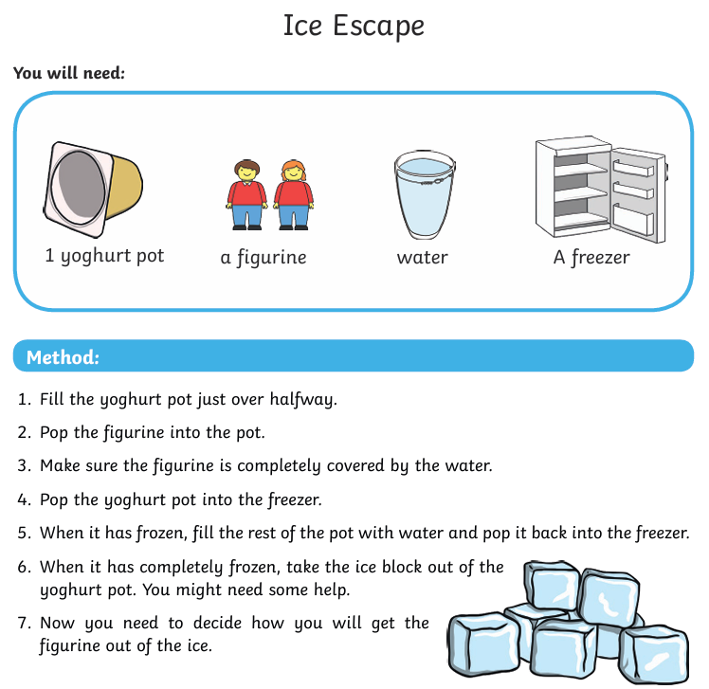

Questions to think about as you work through the activity.
What will happen to the water and why?
How will you get the Lego figure out? Can you think of at least 3 different things to try?
Want to do more….
Freeze extra yoghurt pots with Lego figures and challenge someone to see who can help their Lego figure escape first.
Remember to take photos as you go!

