Homework will be uploaded to the glow blog every Monday. https://blogs.glowscotland.org.uk/sh/ollaberryprimaryschool/

Homework will be marked each week. Please ensure your child brings their homework to school every Monday.

If you have any questions or queries please contact the school by phone or email: jenna.m.peterson@shetland.gov.uk

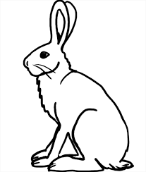
New sound: are for air sound

Spelling List:

- film
- kept
- hare
- care
- share
- scare
- square
- nightmare
- millilitre
10.litre

Practice your spelling words: Look – Cover – Write.

Choose three words and write a sentence for each.

