Homework will be uploaded to the glow blog every Monday. https://blogs.glowscotland.org.uk/sh/ollaberryprimaryschool/

Homework will be marked each week. Please ensure your child brings their homework to school every Monday.

If you have any questions or queries please contact the school by phone or email: jenna.m.peterson@shetland.gov.uk

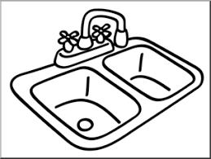
New sound: nk

Practice writing out your spelling words.

Draw a picture and write a sentence for one of your words.

- sink
- pink
- thank
- once
- upon

