Homework will be uploaded to the glow blog every Monday. https://blogs.glowscotland.org.uk/sh/ollaberryprimaryschool/
If you have any questions or queries please contact the school by phone or email: jenna.m.peterson@shetland.gov.uk
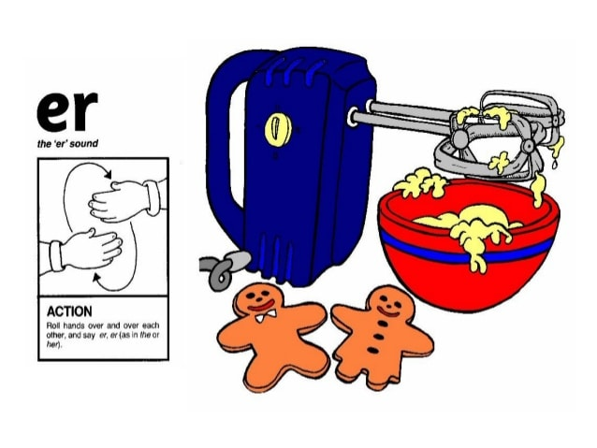
‘er’ Sound

Spelling List:

- drip
- plug
- third
- winter
- bird
- over
- hurt
- butterfly
- thirty
10. forty

Practice your spelling words: Look – Cover – Write.

Choose three words and write a sentence for each.

