Homework will be uploaded to the glow blog every Monday. https://blogs.glowscotland.org.uk/sh/ollaberryprimaryschool/
If you have any questions or queries please contact the school by phone or email: jenna.m.peterson@shetland.gov.uk
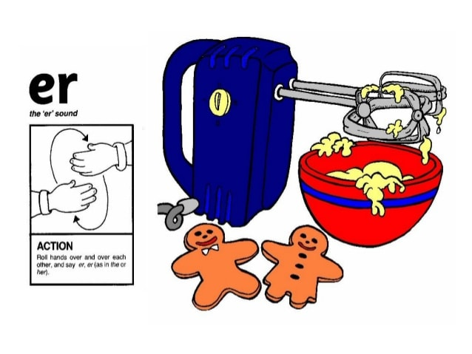
‘nk’ Sound

Roll your hands over each other like a mixer and say ‘er’ ‘er’ ‘er.’

Spelling List:

- mud
- jam
- sent
- term
- summer
- river
- number
- always
- also
10. woodpecker

Practice your spelling words: Look – Cover – Write.

Choose three words and write a sentence for each.

