Homework will be uploaded to the glow blog every Monday. https://blogs.glowscotland.org.uk/sh/ollaberryprimaryschool/
If you have any questions or queries please contact the school by phone or email: jenna.m.peterson@shetland.gov.uk
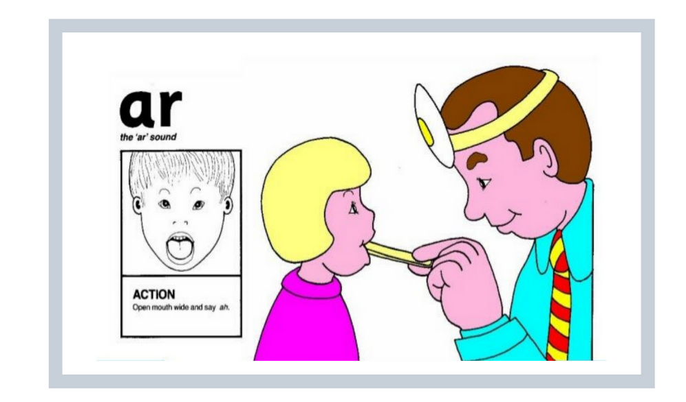
New sound
Your new sound is ‘ar’

Open wide and say ‘ar’ ‘ar’ ‘ar.’

Watch the clip and practice the sound:
(15) 'ar' Words | Phonics Phase 3 - YouTube

You can draw a picture and write a sentence for one of your words.
- start
- smart
- chart
- dart
- part

