Homework will be uploaded to the glow blog every Monday. https://blogs.glowscotland.org.uk/sh/ollaberryprimaryschool/
If you have any questions or queries please contact the school by phone or email: jenna.m.peterson@shetland.gov.uk
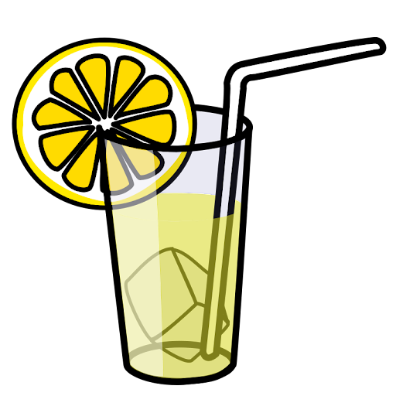
‘nk’ Sound

Spelling List:

- fin
- sob
- left
- sink
- pink
- drink
- thank
- once
- upon
10. thinking

Practice your spelling words: Look – Cover – Write.

Choose three words and write a sentence for each.

