Homework will be uploaded to the glow blog every Monday. https://blogs.glowscotland.org.uk/sh/ollaberryprimaryschool/
If you have any questions or queries please contact the school by phone or email: jenna.m.peterson@shetland.gov.uk
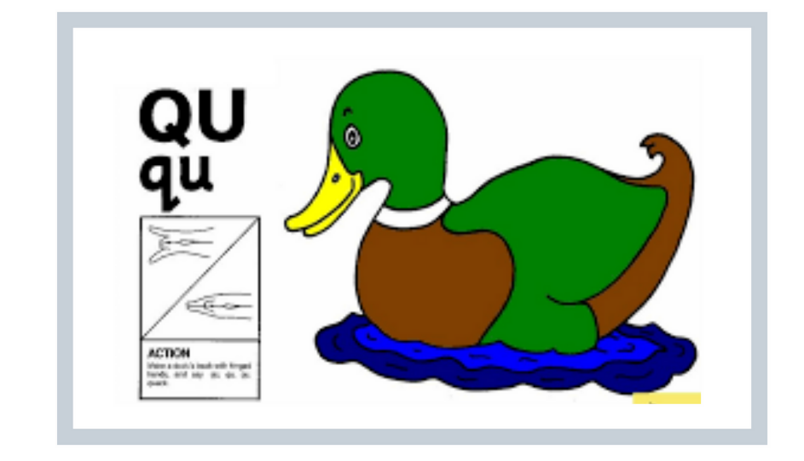
New sound
Your new sound is ‘qu’

Make a duck beak with your hands and say ‘qu’ ‘qu’ ‘qu.’

Watch the clip and practice the sound:
(15) The QU Sound | Phonics Video | Scratch Garden - YouTube

You can draw a picture and write a sentence for one of your words.
- quit
- quid
- quad
- quiz

