Homework will be uploaded to the glow blog every Monday. https://blogs.glowscotland.org.uk/sh/ollaberryprimaryschool/
If you have any questions or queries please contact the school by phone or email: jenna.m.peterson@shetland.gov.uk
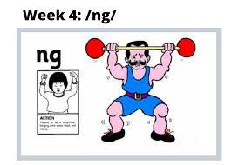
New sound
Your new sound is ‘ng’

Pretend you are a weightlifter, put your arms above your head and say ‘ng’ ‘ng’ ‘ng.’

Watch the clip and practice the sound:
(15) 'ng' Words | Blending Phonics Phase 3 - YouTube

You can draw a picture and write a sentence for one of your words.
- strong
- swing
- bring
- bang
- lung

